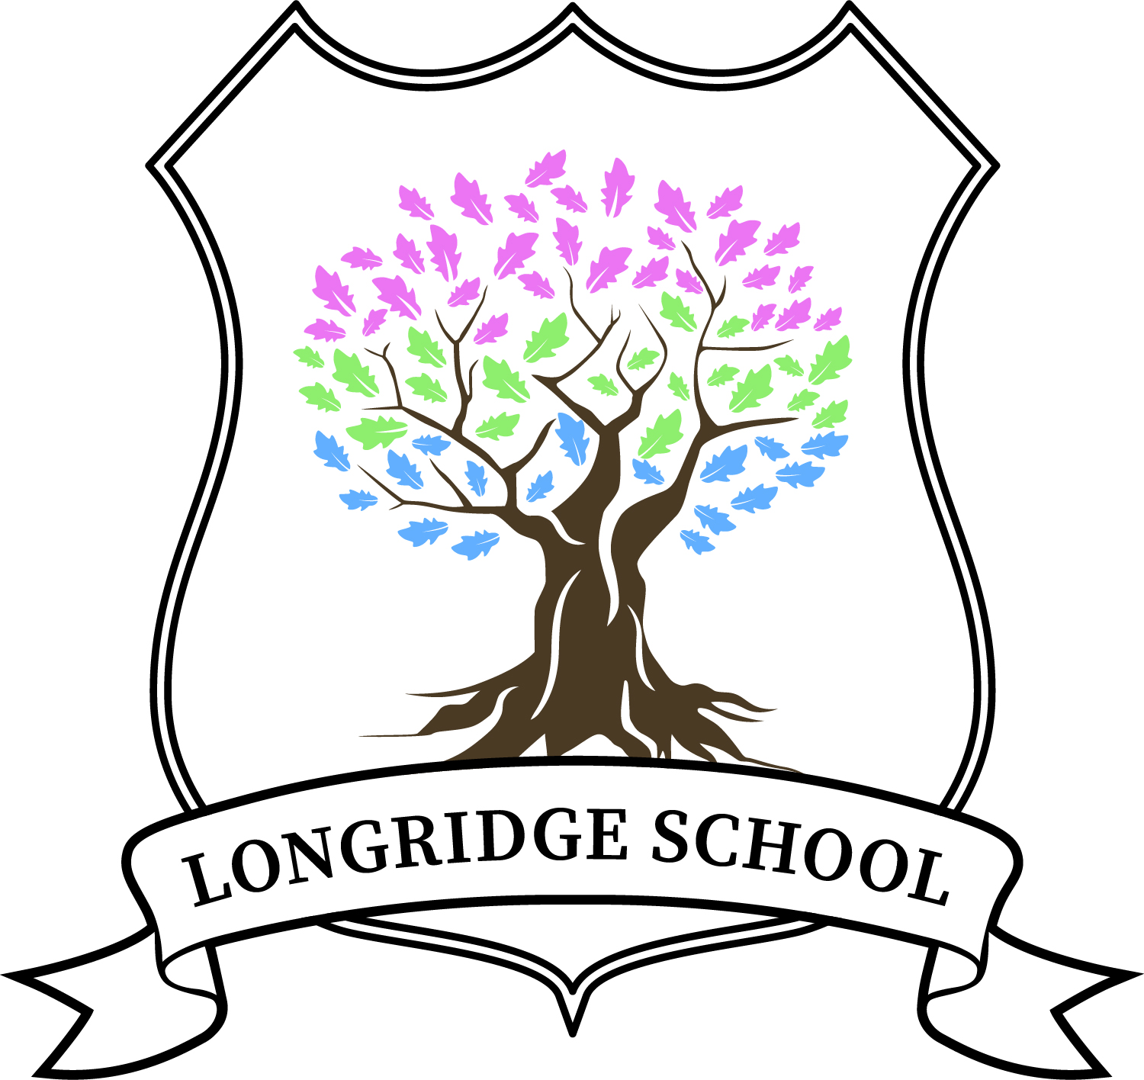

Charging and Remissions Policy



Contents
1. Aims 2
2. Legislation and guidance 2
3. Definitions 2
4. Roles and responsibilities 2
5. Where charges cannot be made 3
6. Where charges can be made 3
7. Voluntary contributions 5
8. Activities we charge for 5
9. Remissions 5
10. Monitoring arrangements 5

1. Aims
The aims of this policy are to:
- Have robust, clear processes in place for charging and remissions
- Clearly set out the types of activity that can be charged for and when charges will be made

2. Legislation and guidance
This policy is based on advice from the Department for Education (DfE) on charging for school activities and the Education Act 1996, sections 449-462 of which set out the law on charging for school activities in England, although as an Independent School the Quantus learning Hub may charge as per it’s agreed articles.

3. Definitions
- Charge: a fee payable for specifically defined activities
- Remission: the cancellation of a charge which would normally be payable

4. Roles and responsibilities
4.1 The Proprietal Board
The board has overall responsibility for approving the charging and remissions policy, but delegates this to the headteacher.
The proprietal board also has overall responsibility for monitoring and implementing this policy.
4.2 Headteacher
The headteacher is responsible for ensuring staff are familiar with the charging and remissions policy, and that it is being applied consistently.
4.3 Staff
Staff are responsible for:
- Implementing the charging and remissions policy consistently
- Notifying the headteacher of any specific circumstances which they are unsure about or where they are not certain if the policy applies
The school will provide staff with appropriate training in relation to this policy and its implementation.
4.4 Parents and carers
Parents/carers/social workers and guardians are expected to notify the headteacher of any concerns or queries regarding the charging and remissions policy.

5. Where charges cannot be made
Below we set out what we cannot charge for in addition to fees. Please also note our provision map information in the appendix which sets out what is included within a standard education package.
5.1 Education
- Admission applications
- Education provided during school hours (including the supply of any materials, books, instruments or other equipment) where this is part of the standard offer.
- Education provided outside school hours if it is part of:
- The national curriculum
- A syllabus for a prescribed public examination that the Student is being prepared for at the school
- Religious education
- Entry for a prescribed public examination if the Student has been prepared for it at the school
- Examination re-sit(s) if the Student is being prepared for the re-sit(s) at the school
5.2 Transport
- Transporting registered Students to or from the school premises, where the local authority has a statutory obligation to provide transport
- Transport provided in connection with an educational visit which is part of the national curriculum
5.3 Residential visits
- Education provided on any visit that takes place during school hours
- Education provided on any visit that takes place outside school hours if it is part of:
- The national curriculum
- A syllabus for a prescribed public examination that the Student is being prepared for at the school
- Religious education
- Supply teachers to cover for those teachers who are absent from school accompanying Students on a residential visit

6. Where charges can be made
Below we set out what we can charge for in addition to standard fees, please again note the provision map in the appendix.
6.1 Education
- Any materials, books, instruments or equipment, where these are bespoke to the individual
- Optional extras (see below)
- Music and vocal tuition for individuals at the request of the child
- Community facilities
6.2 Optional extras
We are able to charge for activities known as ‘optional extras’. In these cases, schools can charge for providing materials, books, instruments or equipment. The following are optional extras:
- Education provided outside of school time that is not part of:
- The national curriculum
- A syllabus for a prescribed public examination that the Student is being prepared for at the school
- Religious education
- Examination entry fee(s) if the registered Student has not been prepared for the examination(s) at the school
- Transport (other than transport that is required to take the Student to school or to other premises where the local authority or governing board has arranged for the Student to be provided with education)
- Board and lodging for a Student on a residential visit
- Extended day services offered to Students (such as breakfast clubs, after-school clubs, tea and supervised homework sessions)
When calculating the cost of optional extras, an amount may be included in relation to:
- Any materials, books, instruments or equipment provided in connection with the optional extra
- The cost of buildings and accommodation
- Non-teaching staff
- Teaching staff engaged under contracts for services purely to provide an optional extra (including supply teachers engaged specifically to provide the optional extra)
- The cost, or an appropriate proportion of the costs, for teaching staff employed to provide tuition in playing a musical instrument, or vocal tuition, where the tuition is an optional extra
Any charge made in respect of individual Students will not be greater than the actual cost of providing the optional extra activity, divided equally by the number of Students participating.
Any charge will not include an element of subsidy for any other Students who wish to take part in the activity but whose parents are unwilling or unable to pay the full charge.
In cases where a small proportion of the activity takes place during school hours, the charge cannot include the cost of alternative provision for those Students who do not wish to participate.
Parental agreement is necessary for the provision of an optional extra which is to be charged for.
6.3 Music tuition
Schools can charge for vocal or instrumental tuition provided either individually or to groups of Students, provided that the tuition is provided at the request of the student, parent or social care
Charges may not exceed the cost of the provision, including the cost of the staff giving the tuition.
Charges cannot be made:
- If the teaching is an essential part of the national curriculum
- For a Student who is looked after by a local authority
6.4 Residential visits
Charges can be made for board and lodging on residential visits, but the charge must not exceed the actual cost.

7. Voluntary contributions
All of our residential students are looked after or vulnerable, and therefore any additional voluntary contributions are not requested. Day students who are not looked after may be asked for additional voluntary contribution as above.

8. Activities or equipment that we charge for
The school may charge for the following equipment/activities:
- Individual laptops (if there is insufficient pupil premium money released by the home authority)
- Equipment/property that is damaged by a student
- Specialist alternative provision for the individual student
- Specialist equipment or resources for the individual student

9. Remissions
In some circumstances the school may not charge for items or activities set out in sections 6 and 8 of this policy. This will be at the discretion of the proprietal board and will depend on the activity in question.
9.1 Remissions for residential visits
Parents who can prove they are in receipt of any of the following benefits will be exempt from paying the cost of board and lodging for residential visits:
- Income Support
- Income-based Jobseeker’s Allowance
- Income-related Employment and Support Allowance
- Support under part VI of the Immigration and Asylum Act 1999
- The guaranteed element of Pension Credit
- Child Tax Credit
- Working Tax Credit
- Universal Credit

10. Monitoring arrangements
The headteacher monitors charges and remissions, and ensures these comply with this policy.
This policy will be reviewed by the headteacher every two years.

Approved by: | C Harvey | Date: 12 Aug 2022
Last reviewed on: | Aug 2022
Next review due by: | Aug 2024

Longridge School Provision Map
The following are all elements included within the standard educational fee charged by New Reflexions:

Standard Educational Package
Up to 25 hours educational programme over five days a week, to suit the individual student
Access to lessons delivered by qualified teachers and Higher Level teaching assistant’s in small classes
Oversight of a Special Educational Needs coordinator to identify learning needs and to set targets
Academic programme consisting of National Curriculum subjects.
Social, moral, spiritual and cultural programme and emotional literacy content within the school curriculum, including student council membership.
Accreditation at all levels up to GCSE through examination boards
Trips appropriate to support the school curriculum
Visitors and speakers to support the school curriculum
Work Experience, as appropriate
Full student annual report and termly academic summary reports
School contributions to all review meetings (LAC, PEP, Annual SEN/EHCP reviews)
School based careers support and termly visits from IAG

Accreditation available within the standard educational package
Functional skills English from Entry level 1 through to Level 1 and 2
Entry Level English at Entry 1, 2 and 3
Functional Skills Maths from Entry Level 1 through to Level 1 and 2
Entry Level Science at Entry 1, 2 and 3
OCR Entry Level bespoke qualifications
Entry level IT and Digital Literacy skills at Entry 1, 2 and 3
Cambridge Nationals
BTEC Home Cooking at Levels 1 and 2
ASDAN bespoke qualifications
AQA Unit Awards
+ All school based resources, group text books and shared ICT.

Please note the above are subject to change due to the normal fluctuation in the qualifications offered by the exam boards.

Educational provision over and above the standard package to be funded in addition or by Pupil Premium, in discussion we may be happy to support one additional provider within the fee.

One to one careers advice from external specialist careers advisors and the creation of specialist reports such as “moving on plans” and “preparation for adulthood” paperwork.
Vocational training placements with specialist providers
Outdoor Education sessions, including access to activities such as;
- Horse riding
- Forest school
Schemes used for individuals with skills deficits such as reading schemes, spelling schemes, which are specialist to that student only.
One to one tuition over and above the standard school timetable
Individual music lessons as requested by the student

