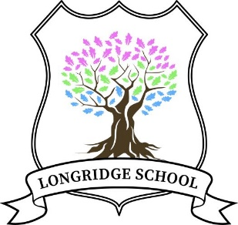

Longridge School
Child Protection and Safeguarding Policy
2023-2024

Key Personnel

Role/organisation | Name | Contact details
Head Teacher and Designated safeguarding lead (DSL) | Carol Harvey | 01785 556710
DSL for New Reflexions | Craig Wilson | 01939 210040
Local authority designated officer (LADO) | Not named  Contact Staffordshire Children’s Advice and Support service (SCAS) | 0300 111 8007 (select option 1)  Out of Hours 0345 604 2886.
Education Safeguarding Advice Service (ESAS) |  | 01785 895836
Emergency Social Care team (out of hours) |  | 0345 604 2886
Chair of Proprietors | Mandy Clarke | 01939 210040 or  07748 923234
Channel helpline | N/A | 020 7340 7264
Education safeguarding website for Staffordshire | Home - Staffordshire Safeguarding Children Board (staffsscb.org.uk)

*Out of hours contact details will be made available to staff
**Any changes to key personnel/holiday/emergency contacts will be shared with the appropriate agencies and Safeguarding Partnerships.

Contents (Ctrl and Click on link to access or Ctrl F to see all headings and sub heading)
Policy Scope and Aims
Safeguarding Statement
Key Terms
Legislation, Standards and Guidance
Linked Policies
Roles and Responsibilities
Professional development and support
Ensuring Safe Practice
Record Keeping and Information Security
Working in Partnership
Teaching our children how to keep safe.
Online Safety
Preventing Radicalisation
Children potentially at greater risk of harm
Child-on-Child Abuse
Staff Safeguarding Concerns: Recognise, Respond, Report
Designated Safeguarding Lead Response
Appendix A: Alternative Provision Quality Assurance Checklist
Appendix B: Child-on-Child Abuse Procedures
Appendix C: File Transfer Record and Receipt
Appendix D: Safeguarding Concern Reporting Form
Any other setting-based appendices

Policy Scope and Aims
This policy applies to anyone working on behalf of Reflexions Education including senior managers and the proprietors, staff, volunteers, contractors, supply staff and students. Reflexions Education refers to New Reflexions’ group of schools include Longridge School.
The policy is publicly available on the school website (or on request from school administrators) so that it can be accessible for our children; their families and anyone visiting and /or working with us.
The policy aims to meet the requirements as outlined in Keeping Children Safe in Education 2023.

Safeguarding Statement
We believe that:

- All children have the right to protection from all types of abuse.
- Everyone has a responsibility to promote the welfare of all children and young people, to keep them safe and to practice in a way that protects them.

This means that we will:
- Not tolerate the abuse of children. This includes never accepting and always challenging or raising concerns about words or actions which downplay, justify, or promote abuse. This applies to anyone who is part of, comes into or works with our schools.
- Be child centred and ensure that we consider the best interests of children in everything that we do.
- Ensure we provide a safe environment for children to learn, grow and develop and feel able to raise any concerns they may have for themselves or others.
- Look out for and respond promptly and appropriately to all identified concerns, incidents or allegations of abuse or neglect of a child.
- Ensure no child or group of children are treated less favourably by us than others.
- Be aware of and take extra positive actions that may be needed to safeguard and promote the welfare of a child(ren) who we know are more vulnerable to experiencing abuse or discrimination.
- Work in partnership with our children, their parents, carers, and other agencies.

Key Terms
Safeguarding and promoting the welfare of children is defined as:
- protecting children from maltreatment,
- preventing impairment of children's mental and physical health or development,
- ensuring that children grow up in circumstances consistent with the provision of safe and effective care; and
- taking action to enable all children to have the best outcomes.
Child Protection is a part of safeguarding and promoting welfare. It refers to the specific activity that is undertaken to protect specific children who are suffering, or are likely to suffer, significant harm.
Abuse is a form of maltreatment of a child. Somebody may abuse or neglect a child by inflicting harm, or by failing to act to prevent harm.
Harm can include ill treatment that is not physical as well as the impact of witnessing ill treatment of others. This can be particularly relevant, for example, in relation to the impact on children of all forms of domestic abuse.
Children may be abused in a family or in an institutional or community setting by those known to them or, more rarely, by others.
Abuse can take place wholly online, or technology may be used to facilitate offline abuse. Children may be abused by an adult or adults, or another child or children.
There are a number of types of abuse and safeguarding issues that could increase the risk that a child could be abused. These are further defined and explained in Part 1, Part 5 and Annex B of Keeping Children Safe in Education 2023.
Staff refers to all those working for or on behalf of our schools, full or part time, temporary or permanent in either a paid or voluntary capacity. The exception to this term is Proprietors.
Proprietors refers to those who are part of the Reflexions Education Proprietal Body.
Child includes everyone under the age of 18.
A Parent refers to birth parents and others who have parental responsibility (as defined by the Children’s Act 1989) or has care of a child.
Female Genital Mutilation (FGM)
There is a specific legal duty on teachers to report this to the police, however all staff need to be aware and speak to the DSL with regard to any concerns about FGM immediately.

Legislation, Standards and Guidance
This policy is based on the following legislation, guidance, standards, and procedures:
Legislation | Statutory National Guidance/Standards | Local Procedures
- Education Act 2002 Section 157 (Independent schools incl Academies and CTC's)  - The Education (Independent School Standards) (England) Regulations 2003  - Children Act 2004 | - Keeping Children Safe in Education and any legislation or guidance (statutory/non-statutory) outlined or referenced within it.  - Working Together to Safeguard Children and any legislation or guidance (statutory or non-statutory) outlined or referenced within it. | - Home - Staffordshire Safeguarding Children Board (staffsscb.org.uk)  - Threshold Framework 2023 - Staffordshire Safeguarding Children Board (staffsscb.org.uk)Allegations of abuse made against a person who works with children - Staffordshire Safeguarding Children Board (staffsscb.org.uk)  - l Operation Encompass | Staffordshire Police

Linked Policies
- Positive Behaviour/Preventing-Bullying Policy  - Staff Code of Conduct  - Health & Safety  - Curriculum intent, implementation and impact policies  - Relationships and Sex Education  - Complaints  - SEND  - Visiting speaker policy | - First Aid Policy  - Acceptable use agreements  - Risk Assessments  - Appraisal, performance management and capability policy  - Data Protection and GDPR  - Attendance policy  - CCTV Policy  - Disability, equality and accessibility policy  - New Reflexions whistle blowing policy

Roles and Responsibilities

We follow the statutory guidance as set out in the latest Keeping Children Safe in Education (and associated documents and guidance); adhering to the roles and responsibilities and expectations identified for:

The Proprietors
Have a strategic leadership responsibility for ensuring we take a whole school approach to safeguarding arrangements as outlined in this policy and that we comply with our duties under Legislation and Guidance. Part 2 Keeping Children Safe in Education outlines their key responsibilities.
The Safeguarding Proprietor is responsible for leading on the governance oversight of safeguarding arrangements; termly meetings with the Designated Safeguarding Lead and reporting back as part of the proprietal board meetings.
The Proprietors safeguarding lead will liaise with the Local Authority in the event of an allegation of abuse made against the Headteacher in line with Ensuring safe staff .
All Proprietors will ensure:
- Each school has a Designated Safeguarding Lead who has the appropriate status and authority to carry out duties of the post and is provided with the time, funding, resources, and support needed to carry out their role effectively.
- Each school has safeguarding policies and procedures in place (as outlined in Part 2 Keeping Children Safe in Education) that are implemented effectively and comply with our duties under Legislation, Standards and Guidance at all times.
- All staff and proprietors are knowledgeable and confident in carrying out their safeguarding duties in line with Professional development and support.
- That the effectiveness and implementation of safeguarding arrangements are robustly overseen by the Proprietor through board reports and challenge within meetings.

The Headteachers:
Are responsible (with the lead support of the Designated Safeguarding Leads in each school) for ensuring safeguarding arrangements are implemented effectively.
This includes:
- Having the overarching responsibility of ensuring the effectiveness of school safeguarding arrangements as outlined in this policy.
- Being accountable and reporting to the Proprietal Body on the effectiveness of school safeguarding arrangements.
- Supporting and promoting a whole school safeguarding culture and ethos as outlined in our Safeguarding Statement. This includes ensuring that Senior Leadership Teams work effectively together and with the Designated Safeguarding Leads, to ensure a Reflexions Education whole approach to safeguarding.
- Take the lead role in Ensuring Safe Practice; including ensuring staff are knowledgeable and confident in their safeguarding practice. The Headteacher is also the lead person responsible for receiving, managing, and referring to/liaising with the Local Authority Designated Officer (with the support of the Designated Safeguarding Lead if different) or any other authorities regarding allegations of abuse made against staff or other organisations/individual who use school premises.
- Enabling the Designated Safeguarding Lead and any deputy(ies) to carry out their roles effectively. This means ensuring they are given sufficient time, training, support, resources, including cover arrangements where necessary.
- Ensuring that all school policies including safeguarding policies and procedures and those required to be in place, are implemented and followed by all staff.

The Designated Safeguarding Lead (DSL):
Takes the lead responsibility for safeguarding and child protection in our schools. Annex C Keeping Children Safe in Education 2023 outlines their key responsibilities. Our Deputy Designated Safeguarding Lead(s) (hereafter referred to as DDSL) support the Designated Safeguarding Lead in the discharge of their responsibilities.
Responsibilities include:
- Ensuring that each school has a child protection policy in place as required by Keeping Children Safe in Education, that is implemented and followed by all staff.
- Being available to deal with safeguarding and child protection during school hours. Out of hours this duty may be given to the DSL at Head office.
- Acting as the point of contact with whom to raise safeguarding concerns for our schools.
- Supporting the Headteacher to Ensure Safe Practice in school.
- Managing safeguarding referrals to the Local Authority; Police and any other statutory authorities or multi-agency risk management arrangements (see Designated Safeguarding Lead Response).
- Working closely with the Proprietors, Headteacher and relevant senior leadership team members to ensure a whole school safeguarding culture and ethos as outlined in our Safeguarding Statement and the implementation of effective safeguarding arrangements, as outlined in this policy.
- Acting as the point of contact to and proactively engaging with the Staffordshire Safeguarding Children’s Partnership arrangements as outlined in Working in Partnership.
- Ensuring children and parents are aware of how they will be encouraged to raise safeguarding concerns and how they will be responded to as outlined in Working in Partnership.
- Act as a source of support, advice, and expertise to all staff; including ensuring that there is ongoing promotion and awareness of safeguarding and children protection in school.
- Ensuring the effective management and oversight of safeguarding information as outlined in Record Keeping and Information Security.
- Maintaining and ensuring access to Professional development and support.

All staff (including students and volunteers):
Are expected to work in line with our Safeguarding Statement and adhere to the policies, processes and systems that support safeguarding as outlined in this policy. This specifically includes:
- Accessing and maintaining Professional development and support to ensure they remain knowledgeable and confident in their safeguarding practice.
- Recognise, Respond and Report Staff Safeguarding Concerns
- Engaging in Safe Practice. This includes raising concerns (however small) about individual behaviour or practices or cultures in schools that compromise the safety of children as outlined in Ensuring safe staff.
- Teaching our children how to keep safe

Professional development and support
To ensure all our staff and proprietors are knowledgeable and confident in keeping children safe in our schools; they will complete the professional development activities as outlined below. We monitor professional development activities and maintain professional development records.
The Designated Safeguarding Lead and Deputy Designated Safeguarding Lead(s) provide all staff with ongoing safeguarding support, advice, and expertise, usually through staff meetings. Staff safeguarding knowledge and competence is overseen as part of the staff induction, appraisal, and performance processes in school. The Designated Safeguarding Lead (and deputy(ies)) receive regular support and supervision through the monthly Staffordshire DSL network briefings, The Staffordshire Learning Network, bi-monthly PSHE Digest Newsletter and through StaffsSCB training.

All Staff (including volunteers)
Activity | Frequency
Receive information on school safeguarding arrangements and procedures as outlined in KCSiE 2023 (Part 1: page 7, paragraph 13). | Induction and each September
Read Keeping Children Safe in Education (KCSiE):  - All Staff: Part 1; Part 5 and Annex B.  - Senior Leadership Team: Entire document  - Staff who do not work directly with children: Annex A | Induction then annually (in September INSET) or when updated.
Complete Safeguarding Awareness Training to enable staff to recognise, respond to and report safeguarding (including online safety and child-on-child abuse) concerns. | Induction, staff meeting updates and formally every 3 years
Complete Prevent Awareness Training appropriate to role | Induction and regularly to not exceed 3 years.
Complete Cyber Security Training | Induction and then annually through our DPO and CEOP ambassador
Receive regular national and local safeguarding updates (including those relating to online safety). | As available, using the Staffordshire Learning Network for updates and the monthly Staffordshire Safeguarding Newsletter and PSHE Digest Newsletter.

Designated Safeguarding Leads (including any deputies)
Activity (in addition to all staff above) | Frequency
Complete Schools Designated Safeguarding Lead Training to a standard as outlined in KCSiE Annex C | On induction in role and then every 2 years
Read Keeping Children Safe in Education in its entirety. | Induction into role then annually (in September) or when updated.
Maintain knowledge and development relating to the role of DSL through relevant training | As required, but at least annually

Proprietors
Activity | Frequency
Complete Safeguarding Training to equip them with the knowledge to carry out their strategic Roles and Responsibilities. | Induction and then every 3 years.
Read Keeping Children Safe in Education  - All Proprietors: Part 1; Part 2 and Annex B.  - Chair & Safeguarding Link Proprietor: Entire document | Induction into role then annually (in September) or when updated).
Complete Cyber Security Training | Induction and regular updates
Complete Prevent Awareness Training appropriate to role | Induction and regular updates.

Staff/Proprietors involved in recruitment of staff (including administration)
Activity (in addition to other relevant above) | Frequency
Read Part 3: Keeping Children Safe in Education | Induction into role then annually (in September) or when updated.
Complete appropriate safer recruitment training (that is in alignment with Part 3 KCSiE) | Induction and every 3 years (or when KCSiE Part 3 is updated)

Ensuring Safe Practice

Safer recruitment
We adopt robust recruitment procedures that deter and prevent people who are unsuitable to work with children from applying for or securing employment or volunteering opportunities in our setting. Lead staff/proprietors involved in recruitment complete additional safer recruitment training; as outlined in Professional development and support. Our recruitment procedures are outlined in are outlined in our Staff Recruitment and Selection Policy and are in alignment with Keeping Children Safe Education 2023: Part 3.
As part of our recruitment and selection processes; we ensure that our commitment to safeguarding and promoting the welfare of children is evident to candidates throughout each stage of the process; with any candidate who is not suitable to work with children being deterred and identified at the earliest point. This information is included on the application information for candidates. We also ensure that all applicants complete a robust application form. We seek suitable references and carry out online social media checks; as well as ensure that there is a focus on the candidate’s knowledge and competency in safeguarding practice as part of the interview processes.
In accordance with Keeping Children Safe in Education 2023: Part 3; we maintain a record of information we have received to confirm the necessary pre-appointment safer recruitment checks are completed on staff (including volunteers, volunteers, supply staff and students), Proprietors and visitors who attend our school in a professional capacity. Contractors are supervised when on site. We complete the checks on staff, volunteers, and Proprietors who we recruit ourselves. For those who are recruited by others; we ensure that we receive written confirmation of the relevant checks completed and check their identification before they are allowed to work unsupervised or engage in regulated activity with children.
Where we do not have all the necessary information or there are gaps in the information; we have robust risk assessment processes in place to ensure that anyone who does not meet the required standards of pre-appointment checks or suitability are not allowed to work unsupervised or engage in regulated activity with children. We reserve the right to refuse access to the school site for any person who we are not assured is safe to work or engage in regulated activity with children.
On appointment; staff (including volunteers) receive a robust induction programme which provides them with the relevant safeguarding knowledge but also clarity on the expected standards of behaviour within and outside of school. Please see Professional development and support.

If any safeguarding concerns of allegations arise relating to a member of staff, proprietors or other person working on our school premises; staff are expected to act in line with Ensuring safe staff and Staff Safeguarding Concerns: Recognise, Respond, Report.

Contractors
We occasionally have agreements with external providers to work in our school most often when completing assessments for our students e.g. Educational psychologists. In these instances we request to see ID and DBS (may include the update service check) information and usually supervise their activity with our children.
Visitors
We have procedures for recording the details and confirming the identity of visitors, including prospective candidates. We ensure that we have control over who comes into the premises so that no unauthorised person has unsupervised access to children. There are robust signing in procedures and all unknown visitor’s ID is checked.

Use of school premises for non-school activities
When we have arranged extra-curricular activities out of school hours which are directly supervised or managed by school staff, this safeguarding policy is to be followed and any concerns should be managed in accordance with Staff Safeguarding Concerns: Recognise, Respond, Report and Designated Safeguarding Lead Response.
We will follow our Ensuring safe staff procedures if we become aware of any allegations relating to an organisation or individual using our school premises.
Where we have sessions or activities which are provided by another person or organisation that is using the school site and not during school time or under direct supervision, we seek assurances that they have the required child safeguarding arrangements in place as an individual/organisation as outlined in Keeping children safe during community activities.. This is regardless of whether children who are on roll at our school access the activity or not.

The arrangements for this will be set out within any transfer of control agreement, (i.e. lease or hire agreement); and failure to comply with these arrangements will lead to termination of the agreement.

Alternative provision
Where we place a child with an alternative provision provider, we continue to be responsible for their safety and welfare and should be satisfied that the provider can meet the needs of the pupil. We do this by completing a thorough visit of the provision, speaking with those providing activities and completing our alternative provider checklist.
Where we are using a service such as transport we obtain written confirmation from the provider that appropriate safeguarding checks have been conducted on individuals i.e., those checks that the school would otherwise perform in respect of its own staff. See Appendix A: Alternative Provision Quality Assurance Checklist.

Ensuring safe staff

Managing allegations (including low level concerns)
We promote an open and transparent culture in which all concerns about the behaviour or conduct of any adults working in, at or on behalf the school are dealt with appropriately.
There are two levels of allegations / concerns:
- Allegations that may meet the harm threshold.
Circumstances where someone working within the school has or may have:
- behaved in a way that has harmed a child, or may have harmed a child and/or
- possibly committed a criminal offence against or related to a child; or
- behaved towards a child or children in a way that indicates that they would pose a risk of harm to children; or
- behaved or may have behaved in a way that indicates they may not be suitable to work with children. This includes any behaviour that may have occurred outside of the school that could pose a transferable risk.
Allegations that someone working in, at or on behalf the school has met the harm threshold should be immediately referred to the Headteacher in person. Staff may be required to provide a written statement at the request of the Headteacher.
If the allegation relates to the Headteacher; this should be immediately verbally reported to the Proprietor with responsibility for schools.
If there is any conflict of interest or immediate risk of harm to a child or; then the person with the concern must ensure Immediate safety and contact the schools DSL and in partnership the Local Authority Designated Officer in accordance with Allegations of abuse made against a person who works with children - Staffordshire Safeguarding Children Board (staffsscb.org.uk)
In most cases, the Headteacher or the Proprietors will lead on managing allegations; with the support of the Human Resources Department and the Designated Safeguarding Leads. They will ensure that Part 4 Keeping Children Safe in Education 2023 and Allegations of abuse made against a person who works with children - Staffordshire Safeguarding Children Board (staffsscb.org.uk) are applied. Any allegations that meet the above criteria will be referred to the Local Authority Designated Officer within 1 working day and we will follow their advice and guidance.
It is essential that any allegations of abuse against a member of staff are dealt with quickly, in a fair and consistent way to effectively safeguard all those involved.
We also have a duty of care towards our staff, and we will provide a named contact for the staff member.
If necessary, we will adhere to our legal reporting duties (such as referring to the Disclosure and Barring Service or Teaching Regulation Agency) as employers as outlined in Part 3 Keeping Children Safe in Education if the criteria for such reporting is met.
- Allegations / concerns that do not meet the harms threshold (Low level concerns).
The term low level does not mean that these concerns are insignificant. A low-level concern is when staff or volunteer may have acted in a way that:
- Is inconsistent with the staff code of conduct, including inappropriate conduct outside of work. Our staff code of conduct outlines examples of what could be considered a low-level concern;
- Does not meet the harm threshold at point 1 above.
Low level concerns should be reported in person to the DSL and/or Head teacher; to embed our culture of openness and transparency. To ensure that our school’s values and expected behaviours are lived, monitored, and reinforced by all staff.
The DSL and/or Head Teacher will gather as much information as possible. The Head teacher will decide the outcome of all low-level concerns (in consultation with the Designated Safeguarding Lead if necessary) raised in line with the staff code of conduct, whistle blowing policy etc. Consideration will be given to whether there is a pattern of behaviour by the individual; or if there is a wider school culture issue and if policies need to be revised, or if all staff guidance or additional staff training is required.

Whistle Blowing
Whistleblowing is the mechanism by which staff can raise concerns in good faith without fear of repercussions. All staff have a duty to raise concerns where they exist about another staff or volunteers practice. This may include attitude or actions of colleague's poor or unsafe practice or potential failures in adhering to the schools' policies, procedures and staff code of conduct.
If staff have such concerns; these should be raised with the DSL and/or Head teacher within each school.
If staff feel unable to raise concerns with the school directly; they can contact NSPCC Whistleblowing Advice Line.

Record Keeping and Information Security
We have a legal duty to act in line with the Data Protection Act 2018 and the UK General Data Protection Regulation (UK GDPR). We have data protection processes in place to ensure that we keep and process (manage) personal information about children, their families; staff and others safely and lawfully. This includes:
- Securely manage electronically held information in line with Meeting digital and technology standards in schools and colleges (see also Online Safety)
- Manage requests for access to personal information we hold (known as subject access requests).
Details of our processes and how to request access to personal information we hold are outlined in our Data Protection and GDPR policy.

Storage and management of safeguarding information (child protection files)
Safeguarding concerns and responses for individual children are kept online within our School Information Management System (Schoolpod) with access provided to just those staff who need it. All staff can enter information. The Designated Safeguarding Lead and/or Head teacher in each school is responsible for ensuring the quality, maintenance, and management of child protection files; as well as using the system to monitor themes and patterns of concern to inform and continue to improve the whole school approach to safeguarding.

Sharing safeguarding information with others
We are proactive in sharing information with each other and others who are working with our children and their families as early as possible; so that children can receive the help and support they need; respond to any safeguarding concerns and where possible prevent abuse.
Staff are expected to share information with one another as part of their work in school about the needs and risks of children on a need-to know basis in line with our Safeguarding Statement so that we keep children safe and promote their welfare. They are not permitted to share information with friends, family, or anyone in the local community outside of their work.

Sharing information with other organisations
Staff should be familiar with and use Information sharing advice for safeguarding practitioners.
As part of our work in partnership with parents and children, consent to share their information with others outside of school should always be sought from a child and their parent(s)/carers unless it is not safe to do so. This includes where seeking consent would:
- Place the child at increased risk of significant harm.
- Place any other at risk of injury.
- Obstruct or interfere with any potential Police investigation.
- Lead to unjustified delay in making enquiries about significant harm.
If a parent or child does not consent to information being shared, the law does not prevent the sharing of information if sharing is necessary for the purpose of keeping a child safe and promoting their welfare. Therefore; staff must make parents and children aware that information may still be shared with other organisations if necessary to help keep their child safe or promote their welfare or if there is another legal basis to so do.
Decisions to share safeguarding information with other organisations will be overseen by the Designated Safeguarding Lead (please also refer to Designated Safeguarding Lead Response).

Transfer of safeguarding information
When a child leaves for a new education setting; the Designated Safeguarding Lead will arrange for the child protection information to be transferred to the new setting no later than within 5 working days of an in-term transfer or within 5 days from the start of the new term. Where the move is planned; the Designated Safeguarding Lead will consider sharing information in advance of the child leaving to help with the child’s transition and to enable any help and support they may need. This is shared separately to any other file and confirmation of receipt of the files should be gained.
If a child is absent from education or Electively Home Educated; we share relevant information with the Local Authority as required by law (please also see Children potentially at greater risk of harm). If the child leaves our setting and does not move to a new education setting; we transfer their child protection information (and any additional information as necessary) to the relevant Local Authority that they reside in line with the local protocol.

Working in Partnership
As is outlined in our Safeguarding Statement; and in order to ensure all children in our schools are effectively safeguarded and their welfare is promoted; we will work in in partnership with our children, their parents/carers and other agencies/partnerships as follows:

Children
Our children are taught how to keep safe; including how and when to share or report to us any worries or concerns they may have about their safety and wellbeing or that of others. We encourage children to share and report worries and concerns by:
- Telling them they can share information with us
- Teaching them about healthy relationships and when to raise concerns

Staff are expected to build trusted relationships with and work in the best interests of children in line with our Safeguarding Statement; and recognise, respond and report Staff Safeguarding Concerns.

We also actively seek children’s views of safety in school through student council and a high level of pastoral support.

Parents/Carers
We recognise the importance of working together with and supporting parents/carers to safeguard and promote the welfare of their children. This includes:
- Communicating to parents/carers how we keep children safe in our schools (including online). This information is made available to all parents on our website. If parents/carers want to raise concerns or complaints about how we keep their children safe; they can do this using our Complaints Policy which is available on our website. We also actively seek parent/carer feedback in our annual questionnaires.
- Encouraging parents/carers to share and report worries and concerns about the safety and welfare of their child(ren) or any other children. We do this by ensuring regular contact with parents/carers in daily ring arounds. Staff are expected to respond to any parents/carers who raises worries or concerns to them either about their child(ren) or others in line with Staff Safeguarding Concerns: Recognise, Respond, Report .
- The Designated Safeguarding Lead will ensure that we work with parents/carers to offer and enable support for children and their families; taking action to safeguard and promote their welfare (see Designated Safeguarding Lead Response) in line with the local arrangements in the area that they live.
- Providing parents/carers with regular information, guidance and information about external support available to them by signposting in regular review meetings (PEP’s/LAC’s etc).

Other agencies/partnerships
As we operate in Staffordshire; we engage and co-operate with our local safeguarding arrangements. Our local safeguarding partnership is the Staffordshire Safeguarding Children Board (staffsscb.org.uk)). We engage and co-operate by:
- Ensuring we effectively safeguard and promote the welfare of children living in Staffordshire in line with Working together to safeguard children and the Staffordshire Safeguarding Community Partnership local criteria for action and assessment; as outlined in the Threshold Framework 2023 - Staffordshire Safeguarding Children Board (staffsscb.org.uk)
- Where children do not live in Staffordshire but attend our schools; we will work in line with the relevant local arrangements in their home area.
- Ensuring we work with other agencies and comply with other pieces of relevant statutory guidance in safeguarding Children potentially at greater risk of harm.
- Supplying information and co-operating in multi-agency forum/meetings, audit or learning reviews as requested by the safeguarding partners.
- Working closely with Staffordshire Safeguarding Childrens Board and other Staffordshire PSHE partnership to ensure we are providing high quality education and support to children in Staffordshire.
- Participating in the local Operation Encompass | Staffordshire Police; an arrangement where police notify schools when a child who attends their school may have been subject or witness to police-attended incidents of domestic abuse. This enables us to provide appropriate emotional or practical support to a child/ren who may have been witness to and victim of domestic abuse. All new parents/carers are sent a letter informing them of our participation in Operation Encompass.
Teaching our children how to keep safe.
We recognise that educating our children in how to keep themselves and others safe both online and in face-to-face situation plays a crucial role in safeguarding them. We have a clear set of values and standards that provide opportunities for children to learn how to keep themselves and others safe; that are demonstrated and reinforced throughout school life and underpinned through -
- Safeguarding Statement
- Positive Behaviour/Preventing Bullying Policy
- Preventing Radicalisation
- Our approach to Online Safety
- Our Personal Social Health Education and Computing curriculum and policies including our RSHE Policy. Our RSHE programme is developed to be fully inclusive of all ages and stages of development and consideration of children’s needs including Children potentially at greater risk of harm; and addresses issues as outlined Keeping Children Safe in Education 2023; Part 2, page 34, paragraph 131.
The DSL, RSHE lead and other key members of the Senior Leadership Team (such as Computing teacher, Mental Health and SENDCo) will work collaboratively to ensure that this is implemented; and being responsive to any safeguarding themes or patterns of concern that arise in school.

Online Safety
The use of information and communication technology (ICT); is a vital part of the everyday functioning of and life in school. We also recognise the important role ICT plays in the lives of our children and their families.
Whilst there are many benefits and strengths in using ICT; there are also a number of risks to children’s welfare and safety in school when using internet enabled technology; which are summarised in the following categories:
- content: being exposed to illegal, inappropriate, or harmful content.
- contact: being subjected to harmful online interaction with other users.
- conduct: online behaviour that increases the likelihood of, or causes, harm to children or others.
- commerce: - illegal, inappropriate, or harmful online commercial activities that can compromise the health and wellbeing or security of children or others.

We adopt a whole school approach to online safety which aims to safeguard and educate our children and their families, staff, visitors and our school in our use and management of ICT (including the use of camera enabled; mobile and personal devices and the ICT systems we have in place). Our acceptable use agreement is signed by staff and students annually.

Our schools approach to online safety;
- all staff are responsible for using enabled devices thoughtfully and applying training around appropriate use at all times.
- Due to our students’ special educational needs and vulnerabilities, all students are closely supervised by a member of our teaching team, when using digital technology in school.
- Our ICT systems provide search management and filtering and blocking systems to keep users safe.
Where there are online safety concerns involving identified children (including child-on-child abuse); we will follow Staff Safeguarding Concerns: Recognise, Respond, Report and Designated Safeguarding Lead Safeguarding Response.
Any school cyber security incidents will be reported to Action Fraud (National Fraud and Cyber Crime Reporting Centre) and, if there is a data breach this will be reported in line with our Data Protection Processes to the Information Commissioners Office. Please also see Record Keeping and Information Security.
Where children are being asked to learn online at home, we follow advice from the Department of Education; Safeguarding and remote education . Our approach to remote learning is bespoke for each individual child and their home situation. Our schools stay up to date with the risks and concerns relating to video calling through updates from our DPO and any advice will be followed
We review our online safety arrangements annually to ensure that we meet the Keeping Children Safe in Education 2023 online safety standards (including the digital standards for filtering and monitoring and cyber security). Any risks arising are further explored with our Data Protection Officer.
All Staff, senior leaders and proprietors are appropriately trained (see Professional Development and Supervision) to enable them to ensure effective online safety arrangements. We will respond to online safety incidents which indicate safeguarding concerns in line with the Staff Safeguarding Concerns: Recognise, Respond, Report and Designated Safeguarding Lead Response sections of this policy.

Preventing Radicalisation
The Prevent Duty for England and Wales (2015) under section 26 of the Counterterrorism and Security Act 2015; places a duty on schools and registered childcare providers to have due regard to the need to prevent people from being drawn into terrorism.
We fulfil our duty by:
- Promoting fundamental British Values as part of our values and curriculum (see curriculum intent policy and SMSC policy). ​
- Ensure that we provide a “safe space” for children to understand and discuss sensitive topics, those linked to terrorism and extremism, and learn (according to their age and level of development) how to question and challenge these ideas in a politically balanced way.
- Be alert to and identify children who may be susceptible to extremist ideology and where it is assessed as appropriate by the Designated Safeguarding Lead; make a Prevent referral (in line with the local Preventing Terrorism Processes)
- Monitor and report any hate based behaviour as part of our Behaviour and Child-on-Child records kept on Schoolpod.
- Outlined in our Relationship Sex Health Education Policy and curriculum intent policy how children are being safeguarded from being drawn into terrorism (including our visiting speakers, see policy).
- Assess the risk of our children being drawn into terrorism, ensuring this is informed by the potential risk in the local area. ​Any identified risks are explored further in staff meetings to ensure awareness.

We regularly review our adherence to the Prevent Duty. Any actions arising from our assessment are included in our school evaluation and improvement action planning processes. These are reported to and overseen by our Governing Body.
All Staff, senior leaders and Governors are appropriately trained (see Professional Development and Supervision) to enable them to ensure that all children, particularly those who may be susceptible to extremist ideology and radicalisation are effectively safeguarded. We respond to children who are identified as being susceptible to an extremist ideology in line with the Staff Safeguarding Concerns: Recognise, Respond, Report and Designated Safeguarding Lead Response sections of this policy.

Children potentially at greater risk of harm
We recognise that whilst all children should be protected, some groups of children, are potentially at risk of greater harm than others (both online and offline). The list below is not exhaustive but highlights some of those groups. Where a child falls into multiple groups above; this potentially further increases their vulnerability.

Children who need a social worker (Child in Need and Child Protection Plans).
Children may need a social worker due to safeguarding or welfare needs. Children may need this help due to abuse and/or neglect and/or complex family circumstances. A child’s experiences of adversity and/or trauma can leave them vulnerable to further harm, as well as educationally disadvantaged in facing barriers to attendance, learning, behaviour, and mental health.

Looked After Children and previously looked after children.
The most common reason for children becoming looked after is as a result of abuse and/or neglect; as well as/or other significant complexities or adversity in their and their family’s life.
New Reflexions schools provide for predominantly Looked After Children and therefore close working relationships with social care are vital. We attend LAC reviews and PEP meetings to ensure these young people’s cases are regularly reviewed and that they have a regular space to be heard, whether in the meeting or as part of the review process.
Our schools have an appointed designated teacher who works with the local authority to promote the educational achievement of registered pupils who are looked after in line with Statutory guidance - Designated teacher for looked-after and previously looked-after children

Children who are absent from education
Children being absent from education for prolonged periods and/or on repeat occasions can act as a vital warning sign to a range of safeguarding issues including neglect or child exploitation; as well as other needs. Our response to persistently absent pupils and children who are absent from education supports identifying such abuse, and in the case of absent pupils, helps prevent the risk of them becoming a child missing education in the future.
New Reflexions follows all the required protocols for reporting children missing from care and works closely with Social Care and the Police to locate children quickly and return them to our care homes. We work in a bespoke way with all our children and complete a home visit if a day student was not attending school to check welfare.
We refer to and use Statutory Guidance on Children missing education to ensure we comply with our duties regarding children missing education. This includes notifying the Local Authority in line with the Children missing from education - Staffordshire County Council process when removing a child from the school roll at standard and non-standard transition points.

Children who are Electively Home Educated.
Many home educated children have an overwhelmingly positive learning experience. We would expect the parents’ decision to home educate to be made with their child’s best education at the heart of the decision. However, this is not the case for all, and home education can mean some children are less visible to the services that are there to keep them safe and supported in line with their needs.
As a fee paying independent service it is rare that a child would move from us to elective home education, however if this was the case we would liaise closely with the placing authority to ensure the best interests of the child are paramount.

Children requiring Mental Health Support
Mental health problems can, in some cases, be an indicator that a child has suffered or is at risk of suffering abuse, neglect or exploitation. Children who have mental health needs will often need early help or support to avoid their safety and welfare being compromised.
We employ a holistic approach to promoting good mental health through consistently high levels of pastoral support, strong relationships with key staff in addition to teaching and learning about emotional well-being in our PSHE curriculum and Well-being Wednesday Activities. New Reflexions has an experienced therapy team who can be consulted for any concerns about the mental health of our learners and referrals for mental health support both within New Reflexions and to external support services can be made, following clear referral and accountability systems; referring to Promoting and supporting mental health and wellbeing in schools and colleges - GOV.UK (www.gov.uk)

Children with Special Education Needs Disabilities or other health issues.
Children with special educational needs or disabilities (SEND) or certain medical or physical health conditions can face additional safeguarding challenges both online and offline.
We recognise that additional barriers can exist when recognising abuse and neglect in this group of children (e.g. assumptions that indicators of possible abuse such as behaviour, mood and injury, relate to the child’s impairment without further exploration, finding solutions to communication barriers).
Longridge students have a diverse range of additional needs including autism, ADHD and/or moderate to severe learning disabilities which increases their vulnerability. Our students benefit from, and may require, continuous high levels of adult support. This ensures that our students form secure and trusting relationships with key adults in school and frequently share their thoughts and worries with these staff members. Some of our students have speech, language and communication difficulties and the school utilises pictorial communication aids and signing to offer alternative ways for our learners to communicate their worries to us. Longridge school adheres to the SEND code of practice and Staffordshire Connects | Special Educational Needs and Disabilities Local Offer and Education for children with health needs who cannot attend school.

Children who are lesbian, gay, bi or trans (LGBT)
The fact that a child or a young person may be LGBT is not in itself an inherent risk factor for harm. However, children who are LGBT can be targeted by other children. In some cases, a child who is perceived by other children to be LGBT (whether they are or not) can be just as vulnerable as children who identify as LGBT.
Longridge school promotes inclusion and celebrates diversity to reduce and/or manage issues/difficulties within school.
Equality Act 2010: advice for schools.
Female Genital Mutilation
Keeping Children Safe in Education explains that FGM comprises “all procedures involving partial or total removal of the external female genitalia, or other injury to the female genital organs”.
FGM is illegal in the UK and a form of child abuse with long-lasting, harmful consequences. It is also known as ‘female genital cutting’, ‘circumcision’ or ‘initiation’.
Possible indicators that a pupil has already been subjected to FGM, and factors that suggest a pupil may be at risk, are set out in appendix 4 of this policy.
Any teacher who either:
- Is informed by a girl under 18 that an act of FGM has been carried out on her; or
- Observes physical signs which appear to show that an act of FGM has been carried out on a girl under 18 and they have no reason to believe that the act was necessary for the girl’s physical or mental health or for purposes connected with labour or birth
Must immediately report this to the police, personally. This is a mandatory statutory duty, and teachers will face disciplinary sanctions for failing to meet it.
Unless they have been specifically told not to disclose, they should also discuss the case with the DSL and involve children’s social care as appropriate.
Any other member of staff who discovers that an act of FGM appears to have been carried out on a pupil under 18 must speak to the DSL and follow local safeguarding procedures.
The duty for teachers mentioned above does not apply in cases where a pupil is at risk of FGM or FGM is suspected but is not known to have been carried out. Staff should not examine pupils.
Any member of staff who suspects a pupil is at risk of FGM or suspects that FGM has been carried out should speak to the DSL and follow local safeguarding procedures.
It has been agreed that regulated professionals with this duty will do the following in Staffordshire:
- Call 101, outlining that this is an FGM referral reporting under the mandatory reporting duty and providing the necessary information requested.
- Further information can be found at:
Female genital mutilation (FGM) | Staffordshire Police

Child-on-Child Abuse
As set out in our Safeguarding Statement; we will not tolerate the abuse of children. This includes where children abuse other children (child-on-child abuse) or use words or actions which downplay or could (if not responded to) lead to abuse.

We want to ensure that no child-on-child abuse takes place in our school. However, we understand that we cannot just rely on children telling us that they are experiencing abuse from other children. Staff should understand that even if there are no reports in school, this does not mean child-on-child abuse is not happening. Staff will be made aware of the signs and indicators of child-on-child abuse as part of their Professional Development and Supervision; which do not just rely upon children telling someone. Staff are expected to follow our Appendix B: Child-on-Child Abuse Procedures

The school monitors patterns of child-on-child incidents including those involving abuse, to ensure that we are aware of and able to minimise and respond to any emerging themes or patterns of behaviours. This helps us to continue to prevent, identify and respond to child-on-child abuse as outlined at the beginning of this section. This monitoring and our responses to it are reported to and overseen by our Governing Body.

Staff Safeguarding Concerns: Recognise, Respond, Report

Recognise
Be alert and curious!
Pay attention to possible signs or indicators of abuse from the child or others either from your own observation or what the child/others tell you:
Appearance
Behaviour
Communication.
Do not just rely on a child telling you (there are lots of reasons why they won’t)
Any child in any family could become a victim of abuse. Abuse and safeguarding issues are complex; and can often involve a child experiencing multiple issues or types of abuse.
Staff should always maintain the attitude that abuse “could happen here”. Staff should be particularly alert to Children potentially at greater risk of harm and vigilant in identifying the signs and indicators which could indicate a concern that a child is being or could be at risk of abuse.
As well as maintaining their Professional development and accessing support; staff can remind themselves of the signs and indicators of abuse and safeguarding issues by referring to: Keeping Children Safe in Education 2023: Part 1 and Annex B. and Signs of Abuse and Neglect - Staffordshire Safeguarding Children Board (staffsscb.org.uk)
Signs and indicators of concern may be evident in spaces and places where children spend time (including when online). They may be present in the child or others around them (including adults or children); in their:
- Appearance
- Behaviour
- Communication
Signs and indicators can be recognised by staff through:
Concerns shared directly by a child: Staff must not rely on children telling them they are experiencing abuse. Children may not recognise; feel ready; know how to or be able to communicate concerns or worries. Staff must therefore act in accordance with our Safeguarding Statement; work in partnership and use professional curiosity and skills in developing trusted and supportive relationships in their everyday work with children.
Observations: In person or online (including online behaviour in school) of a child or someone else (for example a parent, someone working or visiting the school).
Concerns shared by others: either verbally or in written communications. This could be parents; other children; other staff members or other adults who may be working in or with the school or individual children.
Other systems we have in place: For example online filtering and monitoring or information from other agencies through working in partnership etc.
There will be occasions where there are signs and indicators of concern but not enough evidence to indicate that the child is at risk of or experiencing abuse. Signs and indicators could be present for a variety of reasons as well as abuse (for example other family circumstances; health or learning needs); and may act as an early sign for the need for early help and support. In such circumstances; staff are still expected to respond in line with this policy.

Respond
Ensure the immediate safety of the child potentially at risk. If there is immediate danger; take action as necessary to protect the child, others and yourself (including contacting emergency services on 999 and refer child protection concerns)
Apply other relevant policies/procedures (e.g. behaviour; first aid; attendance, staff code of conduct and/or Appendix B: Child-on-Child Abuse Procedures as applicable).
Seek views/gather relevant information (if safe to do so).
Remember: Listen (don’t investigate), reassure (don’t promise) and explain you will be reporting the concerns.

Immediate safety
If a child is in immediate danger; staff must take individual action as necessary to keep the child, others, and themselves safe. They must:
- Contact emergency services if someone is in immediate danger (999).
- If necessary; refer child protection concerns themselves (follow Multi Agency Referral Form (Staffordshire) - Staffordshire Safeguarding Children Board (staffsscb.org.uk)
- Work in line with our Behaviour Policy and Use of reasonable force in schools guidance.
- Report any allegations of harm by adults in a position of trust or unsafe practices in school in line with the Ensuring safe staff.

Other relevant policies/processes
Staff may need to follow other New Reflexions safeguarding policies/processes as applicable along with responding in line with this policy. All staff will immediately consider how best to support and protect the child and any other children who may be at risk or involved; ensuring they act in their best interests. Where there are concerns of child-on-child abuse; Appendix B: Child-on-Child Abuse Procedures should be referred to.

Injuries

We request parents notify us of ay accidents or injuries to their child before attending school. We will make a written record of the notification along with any injuries the child may have. Should a child receive any injuries during school time; staff will follow our accident reporting and first aid procedures.

We use body maps to record information about physical injuries to a child as part of our accident/behaviour/first aid safeguarding concern reporting processes

Seek views and gather information from the child and others.
Where safeguarding concerns are identified; staff should (where it is safe to do so) always seek the views of and directly from:
- Children (where appropriate and depending on the circumstances and their role with children);
- any other people involved in school (only on a need-to-inform/know basis for the purposes of gathering information for the purposes of safeguarding: see Record Keeping and Information Security)
- Their parents (if necessary and depending on the circumstances and their role).
Any uncertainty about seeking views should be discussed with the Designated Safeguarding Lead.
Seeking views from the child/parents means asking them what they think using open questions (What? How? etc) and if they want any help or support. Staff should listen, reassure, and explain that concerns will be reported. Staff should avoid making assumptions, judgments or investigating. Please also refer to When concerns are directly shared by a child.
Views should always be sought unless it is not safe to do so. This includes where seeking views would:
- Place the child at increased risk of significant harm.
- Place any other at risk of injury.
- Obstruct or interfere with any potential Police investigation.
- Lead to unjustified delay in making enquiries about significant harm.
If needs for help and support are identified; parents and children should always be asked for their consent to share information with other organisations so that help and support can be provided to them. If consent is not given; staff should follow guidance in the Recording Keeping and Information Security: Sharing safeguarding information with others section.
Any uncertainty about seeking views should be discussed with the Designated Safeguarding Lead. Decisions to share safeguarding concerns with other organisations without consent will be reported to and overseen by the Designated Safeguarding Lead.
If a child is non-verbal or not able to explain their views themselves due to their age, level of development or needs; then staff should pay attention to how the child may be expressing their views and feelings through their behaviour and use communication tools to help the child share their views. At Longridge, children are supported to express their views and feelings through, pictorial communication books, digital communication apps on ipads and Makaton signing.

When concerns are directly shared by a child
Children are more likely to share their experiences and feelings with someone they know and feel comfortable talking to.
When children share the details of or feelings about abuse; the process of sharing can sometimes take time. Children may not share in full or give staff (and sometimes not the same staff member) pieces of information over time. When they do share, this may not always be verbally or directly; but the child may share in the Appearance, Behaviour or other forms of communication (see Recognise section).
It takes a lot of courage for a child to share that they feel unsafe or are experiencing abuse. There are many reasons why children do not share their experiences (for example, uncertainty, shame, experiences of discrimination, fear, denial or a lack of understanding or ability to recognise and explain their experience).
When children are sharing their concerns; staff should:
- Listen to the child. Please refer to this NSPCC poster.
- Remain calm: the child may stop sharing if they feel the staff member is upset or shocked by what the child is telling them.
- Explain it can’t be a secret. Staff must explain to the child that what they share has to be passed on and to who so that you can help them. Think about when to do this to make sure the child feels safe and can continue to trust you and other staff.
- Reassure and offer comfort to the child (physical touch should not be automatically offered as comfort); recognise their feelings and their courage in sharing their experience. Never deny or minimise what the child is telling you or reprimand them if they decide not to share or for not telling you before.
- Seek the child’s views: use questions or communication tools that help the child to share from their own point of view. Gather information: do not investigate or assume what is happening to the child.
- Explain what will happen next. If you don’t know everything that is going to be done, tell the child that you will make sure that they are kept informed.
- Report and record the conversation immediately as outlined in the Reporting concerns section.
- Seek support if you feel distressed from your line manager, the DSL, a colleague or Health Assured Employee Assistance Service.

Report
Report in person to the Designated Safeguarding Lead as soon as possible.
Record your concerns, decisions, actions and outcomes on the safeguarding recording system.
If concerned about a member of staff or someone else in the school; report in line with Ensuring safe staff.

Report to Designated Safeguarding Lead
All safeguarding concerns must be Reported to the Designated Safeguarding Lead as soon as they are recognised and after the initial response to the child and others. Staff are expected to verbally report their concerns to the Designated Safeguarding Lead.
Where concerns involve an allegation of harm or a low-level concern about someone working in or at the school; staff must follow Ensuring safe staff.

Record concerns
All safeguarding concerns must be recorded by the staff member in writing on the Child protection report or log on Schoolpod. Where physical injuries to a child form part of the evidence of the concern; staff will record information about the physical injuries observed on a Body Map also on Schoolpod.
Each safeguarding concern record should include:
- a clear and comprehensive summary of the concern.
- details of how the concern was followed up and resolved.
- any action taken, decisions reached and the outcome.
If staff are unsure of the recording requirements staff should seek advice from the Designated Safeguarding Lead.

Designated Safeguarding Lead Response
Safeguarding concerns can be raised by staff as above; but may also be raised to the Designated Safeguarding Lead by:
- Children, parents, or visitors to the school.
- Other agencies (see Working in Partnership)
- The school’s ICT filtering and monitoring systems.
The Designated Safeguarding Lead will:
Consider and assess the concern.
Review the information reported; gather any further information as necessary; including conducting a risk and needs assessment if necessary. The Designated Safeguarding Lead will use and refer to the following:
Safeguarding Lead by:
- Children, parents, or visitors to the school.
- Other agencies (see Working in Partnership)
- The school’s ICT filtering and monitoring systems.
The Designated Safeguarding Lead will:

Consider and assess the concern.
Review the information reported; gather any further information as necessary; including conducting a risk and needs assessment if necessary. The Designated Safeguarding Lead will use and refer to the following:
- Keeping Children Safe in Education 2023
- Threshold Framework 2023 - Staffordshire Safeguarding Children Board (staffsscb.org.uk)
- Other Staffordshire Childrens Advice and Support Service - Staffordshire County Council
- If applicable Appendix B: Child-on-Child Abuse Procedures
- When to Call the Police Guidance for Schools

Decide on what action to take.
Once the concern has been considered and assessed; the Designated Safeguarding Lead will decide on action(s) to be taken. They may wish to delegate actions to other members of staff; in the best interests of the child. The DSL will assist the Head teacher with decisions to Ensuring safe staff in school.
In making decisions; the Designated Safeguarding Lead will work in partnership with the Directors, Headteacher; relevant staff/senior leadership team in line with their Roles and Responsibilities and any other organisations as appropriate (see Working in Partnership and Record Keeping and Information Security).
Once the concern has been considered and assessed; the Designated Safeguarding Lead will decide on action(s) to be taken. They may wish to delegate actions to other members of staff; in the best interests of the child. The DSL will assist the Headteacher with decisions to Ensuring safe staff in school.
In making decisions; the Designated Safeguarding Lead will work in partnership with the Headteacher; relevant staff/senior leadership team in line with their Roles and Responsibilities and any other organisations as appropriate (see Working in Partnership and Record Keeping and Information Security).
Actions could include one or more of the below
- Manage internally: in alignment with school policies and processes including offering support to the child and their family through the school pastoral support (Universal/School Early Help) offer in a way which addresses the needs/risks identified. This may also include actions to make locations/infrastructure in school (including online) safer; adapt the curriculum to ensure we are Teaching our children how to keep safe. ; or Working in Partnership .
- Offer Early Help/Targeted Early Help. This could include offering and/or referring the child or their family enhanced or specialist support services to address the needs/risks identified in line with the SSCP Thresholds document and locally available provision. Any referrals for support will require parental consent and will take account of children’s wishes and feelings.
- Raise concerns to Children’s Social Care in line with the Threshold Framework 2023 - Staffordshire Safeguarding Children Board (staffsscb.org.uk)and Home - Staffordshire Safeguarding Children Board (staffsscb.org.uk)
- Report to the Police. If there are any concerns that a crime (including online) may have been committed by someone against or involving a child; concerns will be reported to the Police.

Where there is possible criminal behaviour by a child (including in circumstances of child-on-child abuse); we will take account of When to call the police: guidance for schools and colleges.

Other local referral processes will also be followed as applicable: including referring to relevant multi-agency forums and processes as outlined in Home - Staffordshire Safeguarding Children Board (staffsscb.org.uk)
(e.g. to Prevent Radicalisation; ensure Online Safety; respond to domestic abuse: Multi Agency Referral Form - Staffordshire Safeguarding Children Board (staffsscb.org.uk)

Record actions, decisions, and outcomes.
On the child protection file and in line with Record Keeping and Information Security . This will include assessments and discussions (including meeting notes/minutes) of discussions and meetings with staff or others (see Working in Partnership).

Manage and oversee any ongoing response.
Once the initial actions are taken; the Designated Safeguarding Lead will decide whether there is an ongoing need to actively monitor or manage the safeguarding needs of a child. Where this is decided; they will ensure that the school works in partnership with the child; parents, and any other involved agencies. This may include taking further actions (as outlined above) where concerns escalate.
The SSCB Escalation Policy - Staffordshire Safeguarding Children Board (staffsscb.org.uk) will be used to challenge, resolve and if necessary escalate any concerns the school may have when working with other agencies in safeguarding children.
County Lines
‘County Lines’ is a national issue involving the use of mobile phone ‘lines’ by groups to extend their drug dealing business into new locations outside of their home areas. This issue affects the majority of forces.
A ‘county lines’ enterprise almost always involves exploitation of vulnerable persons; this can involve both children and adults who require safeguarding. The assessment has identified the need for a multi-agency approach at a national, regional and local level. Secure operating bases and Mobile phone ‘lines’ are an essential feature of these enterprises.

A typical county lines scenario is defined by the following components:

a.) A group (not necessarily affiliated as a gang) establishes a network between an urban hub and county location, into which drugs (primarily heroin and crack cocaine) are supplied.
b.) A branded mobile phone line is established in the market, to which orders are placed by introduced customers. The line will commonly (but not exclusively) be controlled by a third party, remote from the market.
c.) The group exploits young or vulnerable persons, to achieve the storage and/or supply of drugs, movement of cash proceeds and to secure the use of dwellings (commonly referred to as cuckooing).
d.) The group or individuals exploited by them regularly travel between the urban hub and the county market, to replenish stock and deliver cash.
e.) The group is inclined to use intimidation, violence and weapons, including knives, corrosives and firearms to intimidate and control members of the group and associated victims.

Our students may be at risk of involvement due to their vulnerabilities and any previous links with urban areas.
Child Sexual Exploitation (CSE)
Child sexual exploitation is a form of child sexual abuse. Sexual abuse may involve physical contact, including assault by penetration (for example, rape or oral sex) or non-penetrative acts such as masturbation, kissing, rubbing and touching outside clothing. It may include non-contact activities, such as involving children in the production of sexual images, forcing children to look at sexual images or watch sexual activities, encouraging children to behave in sexually inappropriate ways or grooming a child in preparation for abuse (including via the internet).
The definition of child sexual exploitation is as follows:
Child sexual exploitation is a form of child sexual abuse. It occurs where an individual or group takes advantage of an imbalance of power to coerce, manipulate or deceive a child or young person under the age of 18 into sexual activity (a) in exchange for something the victim needs or wants, and/or (b) for the financial advantage or increased status of the perpetrator or facilitator. The victim may have been sexually exploited even if the sexual activity appears consensual. Child sexual exploitation does not always involve physical contact; it can also occur through the use of technology.
Like all forms of child sexual abuse, child sexual exploitation:
- Can affect any child or young person (male or female) under the age of 18 years, including 16 and 17 year olds who can legally consent to have sex
- Can still be abuse even if the sexual activity appears consensual
- Can include both contact (penetrative and non-penetrative acts) and non-contact sexual activity
- Can take place in person or via technology, or a combination of both
- Can involve force and/or enticement-based methods of compliance and may, or may not, be accompanied by violence or threats of violence
- May occur without the child or young person’s immediate knowledge (through others copying videos or images they have created and posting on social media, for example)
- Can be perpetrated by individuals or groups, males or females, and children or adults. The abuse can be a one-off occurrence or a series of incidents over time, and range from opportunistic to complex organised abuse
- Is typified by some form of power imbalance in favour of those perpetrating the abuse. Whilst age may be the most obvious, this power imbalance can also be due to a range of other factors including gender, sexual identity, cognitive ability, physical strength, status, and access to economic or other resources.
Child sexual exploitation is a complex form of abuse and it can be difficult for those working with children to identify and assess. The indicators for child sexual exploitation can sometimes be mistaken for ‘normal adolescent behaviours’. It requires knowledge, skills, professional curiosity and an assessment which analyses the risk factors and personal circumstances of individual children to ensure that the signs and symptoms are interpreted correctly and appropriate support is given. Even where a young person is old enough to legally consent to sexual activity, the law states that consent is only valid where they make a choice and have the freedom and capacity to make that choice. If a child feels they have no other meaningful choice, are under the influence of harmful substances or fearful of what might happen if they don’t comply (all of which are common features in cases of child sexual exploitation) consent cannot legally be given whatever the age of the child.
Child sexual exploitation is never the victim’s fault, even if there is some form of exchange: all children and young people under the age of 18 have a right to be safe and should be protected from harm. One of the key factors found in most cases of child sexual exploitation is the presence of some form of exchange (sexual activity in return for something); for the victim and/or perpetrator or facilitator.
Where it is the victim who is offered, promised or given something they need or want, the exchange can include both tangible (such as money, drugs or alcohol) and intangible rewards (such as status, protection or perceived receipt of love or affection). It is critical to remember the unequal power dynamic within which this exchange occurs and to remember that the receipt of something by a child/young person does not make them any less of a victim. It is also important to note that the prevention of something negative can also fulfil the requirement for exchange, for example a child who engages in sexual activity to stop someone carrying out a threat to harm his/her family.
Whilst there can be gifts or treats involved in other forms of sexual abuse (e.g. a father who sexually abuses but also buys the child toys) it is most likely referred to as child sexual exploitation if the ‘exchange’, as the core dynamic at play, results in financial gain for or enhanced status of the perpetrator.
Where the gain is only for the perpetrator/facilitator, there is most likely a financial gain (money, discharge of a debt or free/discounted goods or services) or increased status as a result of the abuse.
If sexual gratification, or exercise of power and control, is the only gain for the perpetrator (and there is no gain for the child/young person) this would not normally constitute child sexual exploitation, but should be responded to as a different form of child sexual abuse.
Child sexual exploitation can occur in all communities and amongst all social groups and can affect girls and boys. All practitioners should work on the basis that it is happening in their area.
Child sexual exploitation is occurring across the country but is often hidden so prevalence data is hard to ascertain. All practitioners should be open to the possibility that the children they work with might be affected.
Students aged 12-15 years of age are most at risk of child sexual exploitation although victims as young as 8 have been identified, particularly in relation to online concerns. Equally, those aged 16 or above can also experience child sexual exploitation, and it is important that such abuse is not overlooked due to assumed capacity to consent. Account should be taken of heightened risks amongst this age group, particularly those without adequate economic or systemic support.
Though child sexual exploitation may be most frequently observed amongst young females, boys are also at risk. Practitioners should be alert to the fact that boys may be less likely than females to disclose experiences of child sexual exploitation and less likely to have these identified by others.
Child sexual exploitation affects all ethnic groups.
“Working Together” makes clear the requirements for holistic assessment. Sexual exploitation is often linked to other issues in the life of a child or young person, or in the wider community context. Practitioners should be alert to the fact that child sexual exploitation is complex and rarely presents in isolation of other needs and risks of harm (although this may not always be the case, particularly in relation to online abuse). Child sexual exploitation may be linked to other crimes and practitioners should be mindful that a child who may present as being involved in criminal activity is actually being exploited.
Practitioners should not rely on ‘checklists’ alone but should make a holistic assessment of vulnerability, examining risk and protective factors as set out in the statutory guidance Working Together.
Sexual exploitation can have links to other types of crime. These include:
- Child trafficking;
- Domestic abuse;
- Sexual violence in intimate relationships
- Grooming (including online grooming)
- Abusive images of children and their distribution
- Drugs-related offences
- Gang-related activity
- Immigration-related offences
- Domestic servitude.
The following vulnerabilities are examples of the types of things children can experience that might make them more susceptible to child sexual exploitation:
• Having a prior experience of neglect, physical and/or sexual abuse;
• Lack of a safe/stable home environment, now or in the past (domestic violence or parental substance misuse, mental health issues or criminality, for example);
• Recent bereavement or loss;
• Social isolation or social difficulties;
• Absence of a safe environment to explore sexuality;
• Economic vulnerability;
• Homelessness or insecure accommodation status;
• Connections with other children and young people who are being sexually exploited;
• Family members or other connections involved in adult sex work;
• Having a physical or learning disability;
• Being in care (particularly those in residential care and those with interrupted care histories); and
• Sexual identity.
Not all children and young people with these vulnerabilities will experience child sexual exploitation. Child sexual exploitation can also occur without any of these vulnerabilities being present.
Potential indicators of child sexual exploitation.
Children rarely self-report child sexual exploitation so it is important that practitioners are aware of potential indicators of risk, including:
- Acquisition of money, clothes, mobile phones etc. without plausible explanation
- Gang-association and/or isolation from peers/social networks
- Exclusion or unexplained absences from school, college or work
- Leaving home/care without explanation and persistently going missing or returning late
- Excessive receipt of texts/phone calls
- Returning home under the influence of drugs/alcohol
- Inappropriate sexualised behaviour for age/sexually transmitted infections
- Evidence of/suspicions of physical or sexual assault
- Relationships with controlling or significantly older individuals or groups
- Multiple callers (unknown adults or peers)
- Frequenting areas known for sex work
- Concerning use of internet or other social media
- Increasing secretiveness around behaviours
- Self-harm or significant changes in emotional well-being.
Practitioners should also remain open to the fact that child sexual exploitation can occur without any of these risk indicators being obviously present. Practitioners should also be alert to the fact that some risk assessments have been constructed around indicators of face-to-face perpetration by adults and may not adequately capture online or peer perpetrated forms of harm. It is also important to remember that risk assessments only capture risk at the point of assessment and that levels of risk vary over time, and that the presence of these indicators may be explained by other forms of vulnerability rather than child sexual exploitation.
Recent national reviews have also demonstrated the challenges in engaging victims of CSE. Many may feel too ashamed at what has happened to them to come forward but may also be unable or unwilling to see themselves as victims in the first instance.

Young people have suggested that the following should be at the heart of all planning and decision making about CSE:
- Don’t make assumption about who I am and what I need
- Help make me safe and stop it happening
- It’s not just me
- Punish the right people
- Don’t think there is a quick fix

Managers should be aware of the local protocols and CSE strategies and discuss concerns prior to or on admission for the young people who are accommodated within their homes.
Child Criminal Exploitation (CCE)
Some specific forms of CCE can include children being forced or manipulated into transporting drugs or money through county lines, working in cannabis factories, shoplifting or pickpocketing. They can also be forced or manipulated into committing vehicle crime or threatening serious violence to others.
Children can become trapped by this type of exploitation, as perpetrators can threaten victims (and their families) with violence or entrap or coerce them into debt. They can be coerced into carrying weapons such as knives or begin to carry a knife for a sense of protection from harm. As children involved in criminal exploitation often commit crimes themselves (particularly older children), they are not always recognised and treated as victims despite the harm they have experienced. They may still have been criminally exploited even if it appears they agreed or consented to the activity.
It is important to note that the experience of girls who are criminally exploited may be different to that of boys. It is also important to note that both boys and girls being criminally exploited may be at higher risk of sexual exploitation.

Last Reviewed | August 2023
Next Review | August 2024
Reviewed by | Executive Head Teacher and Proprietors

Appendix A: Alternative Provision Quality Assurance Checklist

Alternative Provision Quality Assurance Checklist

Name of alternative provision:
Name of person completing checklist (from host school):
All agencies and settings who place pupils at alternative provision MUST quality assure the placement.
This quality assurance document must be completed prior to working with a new alternative provision and annually thereafter.

 |  |  |  | On file/ evidence of check | Date & Initial
1 | If this quality assurance check is a review, please confirm the date of previous assurance check.
2 | Is the alternative provision registered as an independent school with the DfE? Y/N  The criteria to be registered as an independent school is that;  - full-time¹ education is provided for five or more pupils of compulsory school age  Or  -full-time education is provided for one or more pupils with an EHC plan or who is “looked after” by a local authority  1 - There is no legal definition of what constitutes ‘full-time’ education. However, DfE would consider an institution to be providing full-time education if it is intended to provide, or does provide, all, or substantially all, of a child’s education.
3 | What is the provider’s DfE number? (If applicable)
4 | Copy of signed Service Level Agreement (SLA) /contract (attached)
5 | Is there a clear governance structure within the Alternative provision? Y/N
6 | Does the referral process include the requirement for a detailed pupil profile from the host school prior to agreement of placement? Y/N
7 | Pupil’s attendance should be monitored daily. Is this included in the SLA? Y/N  Copy of providers Attendance policy attached.
8 | Is there a procedure for when pupils fail to attend or the placement breaks down? Y/N
9 | Is there adequate access to resources for all pupils who access the provision? Y/N
10 | Is there inclusive practice with regards to positive behaviour management, attendance and punctuality? Y/N  - Pro-actively promote and support the regular attendance of pupils  - Effective reward/incentive strategies to promote participation
11 | Is there regular assessment and review of pupil progress? Y/N  Provision agree to share weekly progress reports
12 | Are risk assessments completed for activities that pupils may undertake? Y/N (copy attached)
13 | Is there a full and clear pupil induction procedure regarding health and safety and fire evacuation? Y/N
14 | Are there robust procedures in place (including information sharing that are referenced in the SLA) to safeguard children in line with KEEPING CHILDREN SAFE IN EDUCATION? Y/N  Copy of providers Safeguarding/Child protection policy attached.
15 | Has evidence of staff receiving accredited child protection training been seen? Y/N  Has evidence of DSL receiving training for their role been seen? Y/N  Have contact details for DSL been provided? Y/N (attached).
16 | Copy of public liability insurance document attached.
17 | Is there a policy for when members of staff are working alone with pupils? Y/N (copy attached)
18 | Does the provider have an online safety policy in line with KEEPING CHILDREN SAFE IN EDUCATION? Y/N (copy attached)
19 | Copy of health and safety policy attached.
20 | Has written confirmation from the provider that staff vetting checks have been undertaken been received? Y/N  Checks include;  - an identity check;  - a barred list check;  - an enhanced DBS check/certificate;  - a prohibition from teaching check;  - further checks on people who have lived or worked outside the UK  - a check of professional qualifications, where required; and  - a check to establish the person’s right to work in the United Kingdom.  Has confirmation of these checks been added to the Single Central Record?
21 | Is there a Designated First Aid Officer and suitable equipment available? Y/N  - Qualified First Aiders identified  - Recording system for accidents including informing host school and home  - Historical or current RIDDOR investigations  - Evidence of full first aid kit
22 | Has confirmation been received from the provider that a representative will attend or contribute to multi-agency meetings when necessary? Y/N
Action Plan
If ‘no’ is answered to any of the questions in Part 2 an action plan must be formulated to obtain information
Action reference number. |  | Area for improvement | Intended action

Signed by host school: Date:

Signed by Alternative Provision: Date:

Appendix B: Child-on-Child Abuse Procedures
Addressing child-on-child abuse: a resource for schools and colleges (farrer.co.uk)
We aim to prevent, identify, and respond to child-on-child abuse at the earliest opportunity by:
- Expecting all staff and Proprietors across our schools to ensure they are adhering to and promoting the commitments we make in our Safeguarding Statement.
- Ensuring staff are aware of and respond to signs and indicators of child-on-child abuse. This includes ensuring that our Designated Safeguarding Lead and other relevant staff have completed training in how to assess and respond to child-on-child abuse. For further detail; please refer to Professional Development and Support.
- Being clear how we expect our children to behave towards one another. Our Behaviour Policy outlines these expectations; how the school will support our children to understand and fulfil them; and how we will prevent and respond to behaviour which falls below our expected standards (including all forms of bullying see our Preventing Bullying Policy). Where behaviour also indicates child-on-child abuse; staff will adhere to the processes outlined in this section.
- Ensuring we are Teaching our children how to keep safe..
- Making sure that children who experience or are at risk of experiencing abuse from other children are identified, feel supported and safeguarded from further harm.
- Making sure that children who have caused or are identified as being at risk of being abusive in their behaviour towards other children are identified, supported and safeguarded from engaging in further harmful behaviour.
- Making sure that we are taking positive action to ensure that Children who are more vulnerable to child-on-child abuse are not disproportionately impacted by child-on-child abuse in our schools.
- Ensuring appropriate supervision at a higher level than in mainstream environments to support and manage our young people, some of whom have speech language and communication difficulties learning disabilities and autism which can impact on their understanding of appropriate social interactions with others.

What is child-on-child abuse?
Child-on-child abuse:
- Is when a child or group of children inflicts harm or fails to act to prevent harm to another child.
- Actions that cause harm can be a single serious incident or a pattern of incidents.
- Harm caused to a child can be physical, emotional and/or psychological; and can include witnessing the ill treatment of others.
- Can happen both inside and outside of school; at home or someone else’s home; in public spaces and online. In the school context; we know that child-on-child abuse can take place in spaces and at times of the school day where children are less likely to be supervised. We also know that where child-on-child abuse is taking place outside of school (including online) this abuse can also continue and have an impact on a child when they are at school.
- Can be defined in different ways (examples are outlined in Keeping Children Safe in Education 2023: Part 1; pages 12-13 and Part 5; pages 106-109).
- A child may experience one or multiple types of child-on-child abuse at the same time.

Children who are more vulnerable to child-on-child abuse
Please read this alongside Children potentially at greater risk of harm.
Children who are perceived to be different to others can be particularly vulnerable to child-on-child abuse. When children are abused by other children; there is more often than not a misuse of power or privilege by the child(ren) causing harm. This can have a significant impact on the emotional development and mental wellbeing of the child who is being harmed; and lead them to feel isolated, unsafe, and traumatised.
Children who harm others may have additional or complex needs. Harmful behaviour by children can also be a sign or indicator that a child has an unmet need or could indicate that they themselves are at risk of or are experiencing/have experienced abuse or neglect or some other form of adverse experience in their life. Children who harm other children may have power or privilege over a child(ren) they are causing harm to but can also be powerless or vulnerable in other part of their lives.
Child-on-child abuse is harmful to all children involved.
Evidence indicates that children from particular groups are more vulnerable to child-on-child abuse. This includes children who:
- Have special education needs and/or disabilities and/or health issues.
- Have already been and/or are experiencing abuse or some other kind of adversity or trauma. This includes children who are looked after or who have a social worker due to safeguarding concerns.
- Are eligible for free school meals. Socio economic inequality can increase incidents of bullying.
- Are from Black, Asian and/or other minoritized ethnic communities (including travelling communities and children for whom English is an additional Language). These children are more likely to be the target of hate-related behaviour/crime. They are less likely to be identified as children who are being harmed and more likely to be over identified as children who are a risk of causing harm. This is known as adultification bias.
- Identify as Lesbian Gay, Bi-Sexual; Transgender (LGBT). These children are more likely to be the target of bullying and/or hate-related behaviour/crime and harmful sexual behaviour and abuse.
- Are female. Girls are more vulnerable to harmful sexual behaviour and abuse in intimate personal relationships.
- Are male. Boys and are more vulnerable to experiencing bullying; particularly that which is physical in nature (including being forced to carry out initiation or other acts which humiliate or degrade: known as hazing).
Where a child has several differences and would fall into multiple groups above; this further increases their vulnerability.

When is child-on-child behaviour considered abusive?
We recognise the importance of distinguishing between behaviour that is developmentally appropriate, problematic, or harmful. Harmful behaviour is abusive. It can also (but not always) include physical abuse.
In considering whether behaviour is abusive; staff should consider:
- The impact on the child(ren) affected by the behaviour: Any behaviour that is likely to have an impact on a child’s physical and emotional health and development should be considered potentially harmful. The greater the impact of the behaviour on the child’s health and development; the greater level of harm caused to them.

The needs and circumstances of the child who is identified as being potentially harmed should always be considered. This should also include ensuring that their wishes and feelings are sought and recognised in considering the impact upon them.
Even where children do not/are not able to express their wishes and feelings; staff should also pay attention to other potential signs/indicators of abuse (please refer further to Staff Safeguarding Concerns: Recognise, Respond, Report)

Children raising child-on-child concerns either for themselves or others will be taken seriously and never be given an impression they are creating a problem.

- The behaviour of the child(ren) who is/are causing harm: It is important to consider the behaviour of children on a continuum; taking account of their age and level of development; as well as any other needs or circumstances that may influence their behaviour (for example a child who is causing harm to other children could be an indication that they have unmet needs; or may be a sign or indicator that they are experiencing abuse, or are experiencing some other adverse experience which is having an impact upon them).
Features of abusive behaviour can include:
- A pattern of similar behaviour (this can include lower-level problematic behaviours that have occurred over time that have begun to increase in frequency or seriousness)
- A misuse of power over the child who is being harmed. (please also see children who are more vulnerable above).
- Victimisation of the child who is being harmed. This could also include circumstances where the child causing harm is supported or joined by other children.
- Intrusive behaviour; not considering or enabling the child being harmed to freely agree and/or consent to the behaviour.
- An element of control; coercion and/or force.
- Physical/sexual violence (this does not always have to be present; but where it is so would heighten the level of concern).
- Evidence that a child is actively seeking, planning or getting enjoyment or pleasure from causing harm would also heighten concern.

Our response to child-on-child abuse
In most instances, we will use our Positive Behaviour Policy to manage the conduct of children towards each other. However, where behaviour is considered abusive or indicates safeguarding concerns; then staff will also need to raise such concerns to the Designated Safeguarding Lead in line with the Staff Safeguarding Concerns: Recognise, Respond, Report section.
In responding to any concern of child-on-child abuse; we will take account of:
- Part 5 Keeping Children Safe in Education 2023.
- Use of reasonable force in schools
- Searching, screening and confiscation at school
- Sharing nudes and semi-nudes: advice for education settings working with children and young people
- When to call the police: guidance for schools and colleges.

Risk and needs assessment.
All staff will immediately consider how best to support and protect all children involved in child-on-child abuse incidents; ensuring they act in their best interests.
We may deem it necessary to complete a formally recorded risk and needs assessment for all children involved in child-on-child abuse incidents. The decision to complete a formal risk assessment will be taken by the Designated Safeguarding Lead. This formal assessment will always take place where there evidence of violent or abusive behaviour.
The purpose of the risk and needs assessment is to safeguard all children involved (including children who may not be at the school, such as siblings) and will clearly outline the strategies to be put in place to mitigate risk and address any identified needs.
The risk and needs assessment will be completed; taking account of information from all key staff (and relevant involved professionals) working with the children, as well as their parents/carers. It will also include the views and feelings of the children; where this is safe and appropriate to do so.
The risk assessment will be shared will all staff and relevant involved professionals who work with the children; as well as parents and carers. It will respond to any changes in behaviour and will be regularly updated and evaluated to assess impact.
Our template risk and needs assessment can be found below.

Response
The parents/carers of all involved children will be notified of and involved in our response. We will only share the details of other children to parents/carers who do not have parental responsibility for them where we have consent to do so or where a decision has been taken to share to enable them to effectively safeguard their child (please also refer to Record Keeping and Information Security)
The risk and needs assessment will inform the response taken. The following responses will be considered; (more than one response can be considered):
- Manage internally in alignment with our Positive Behaviour Policy and pastoral support offer in a way which addresses the needs/risks identified. Any sanctions imposed on the child causing harm will be proportionately balanced with any other responses (such as police involvement) and take accounts of risks and needs; as well as the ongoing impact on/risk to the child who has been harmed or others. This may also include actions to make locations/school infrastructure (including online) safer; adapt our curriculum to ensure we are Teaching our children how to keep safe.; or Working in Partnership.
- Offer Early Help/Targeted Early Help. This could include offering and/or referring any child involved to enhanced or specialist support services to address the needs/risks identified in line with the Threshold Framework 2023 - Staffordshire Safeguarding Children Board (staffsscb.org.uk) and locally available provision. Any referrals for support will require parental consent and will take account of children’s wishes and feelings.
- Raise concerns to Children’s Social Care in line with the Threshold Framework 2023 - Staffordshire Safeguarding Children Board (staffsscb.org.uk).
- Report to the Police. We will take account of When to call the police: guidance for schools and colleges.

Recording and monitoring
All child-on- child abuse concerns and responses will be recorded and stored on the child protection records of all involved children (Please refer to Record Keeping and Information Security). Child-on-child incidents that do not indicate abuse or raise safeguarding concerns are recorded in line with our Behaviour Policy on Schoolpod.

Appendix D: Safeguarding Concern Reporting Form

Can be found on Schoolpod.

Appendix E: Harmful Sexual Behaviour Risk Assessment
When completing a risk assessment, advice in statutory and non-statutory guidance should be considered. Whilst not intended to be an exhaustive list, can include:
Department for Education: Keeping children safe in education: This statutory guidance sets out the legal duties you must follow to safeguard and promote the welfare of children and young people under the age of 18 in schools and colleges. In the context of harmful sexual behaviour, the most relevant section of this is section 5.
Department for Education: Sharing Nudes and Semi-Nudes: Advice for Education Settings working with Young People: This non-statutory advice aims to support designated safeguarding leads (or equivalents) and senior leadership teams in education settings in England in responding effectively to incidents involving the sharing of nudes and semi-nudes.
Department for Education: Working together to safeguard children: Working together to safeguard children (usually referred to as just Working Together) is statutory guidance produced by the government which outlines how practitioners working with children, young people and families should work together in order to ensure that children and young people remain safe from harm. It should also be produced in line with, and link to the following school/academy policies:
• Child protection and safeguarding policy
• Whistleblowing policy
• Behaviour policy • Anti-bullying policy
• Online safety policy
• Acceptable Use Agreements
• Curriculum Policies
• Use of outside agencies
The risk assessment is split into two sections. First is a summary to capture details about the child and any other surrounding safeguarding issues. The second section is the full risk assessment to detail the incident(s) that have led to the need for this risk assessment to be carried out, provide evidence and log any further concerns

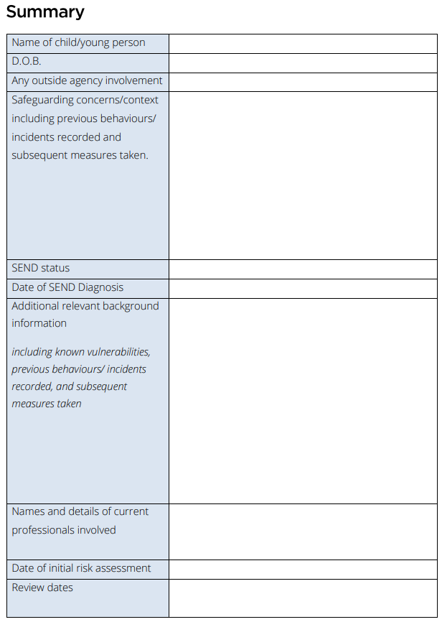
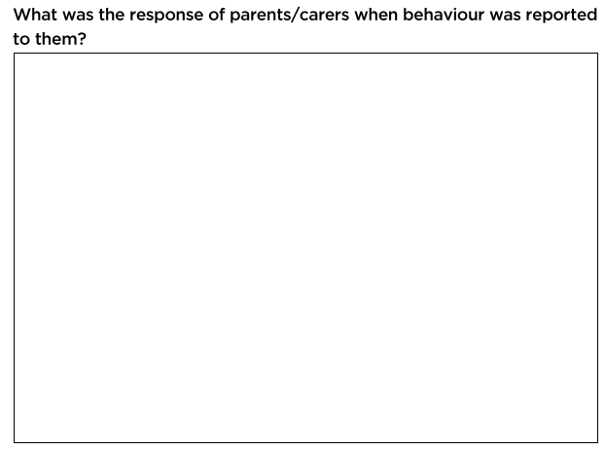
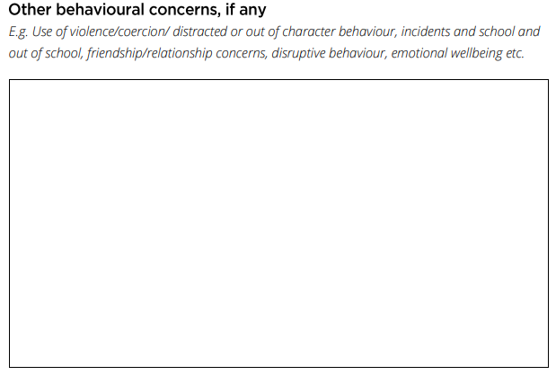

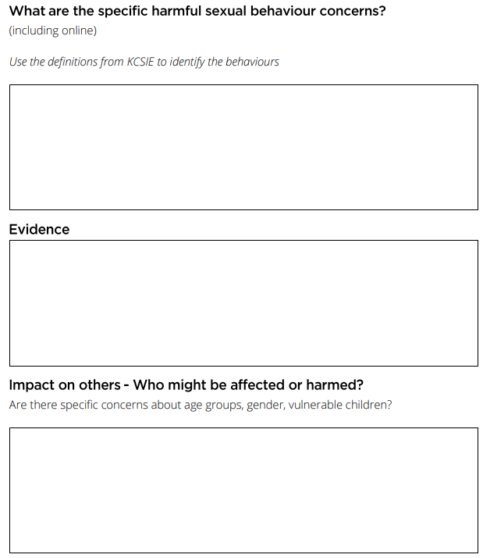
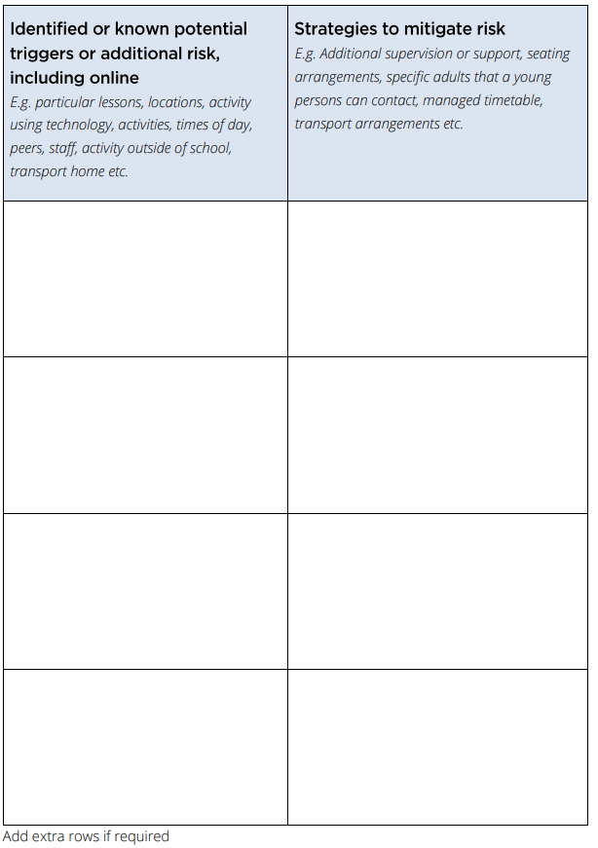

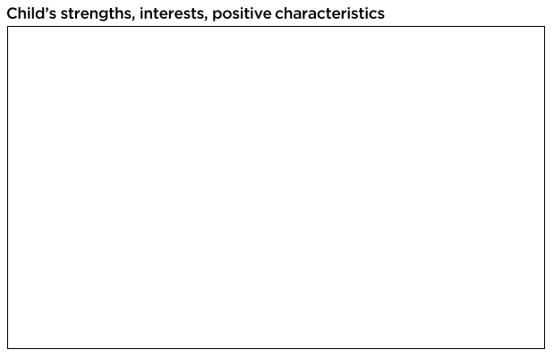
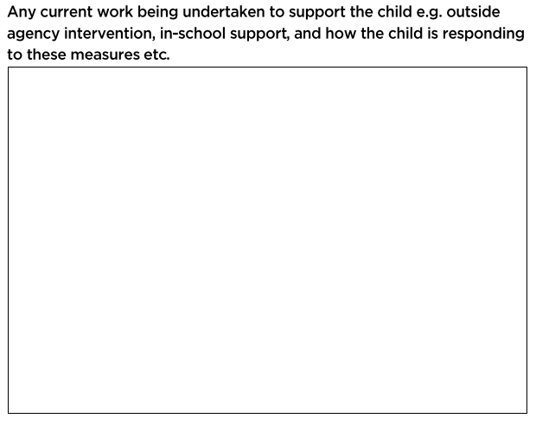

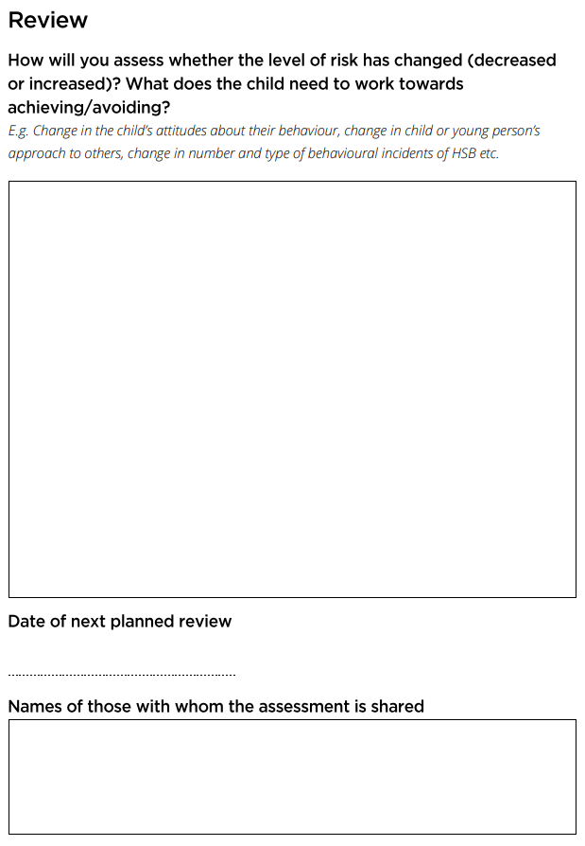

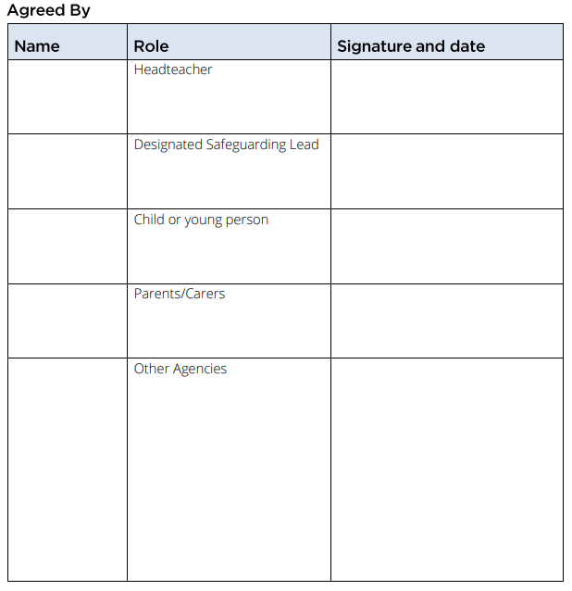

harmful-sexual-behaviour-service-risk-assessment.pdf (swgfl.org.uk)

S576 Education Act 1996
Examples of what could be included in the categories is further detailed in Keeping Children Safe in Education 2023 (Part 2; page 35-36)
See Understanding trauma and adversity | Resources | YoungMinds for further information.
Evidence sources: - Keeping Children Safe in Education 2023; Part 2: Children potentially at greater risk of harm. - Prevalence of bullying (anti-bullyingalliance.org.uk). - Safeguarding d/Deaf and disabled children | NSPCC Learning; - Safeguarding children from Black, Asian and minoritised ethnic communities | NSPCC Learning; - Safeguarding LGBTQ+ children and young people | NSPCC Learning; - Spotlight #3: Young people and domestic abuse | Safelives. - Addressing child-on-child abuse: a resource for schools and colleges (farrer.co.uk)
Adultification bias within child protection and safeguarding (justiceinspectorates.gov.uk)
Adapted from Hackett Continuum as described in Understanding sexualised behaviour in children | NSPCC Learning. When drawing on Hackett’s continuum, in order to assess the seriousness of other (i.e. non Harmful Sexual Behaviour) alleged behaviour, it should be borne in mind that there are some aspects of Hackett’s continuum which may not of course be relevant or appropriate to consider (see Farrer and Co (2022) page 35-36)

