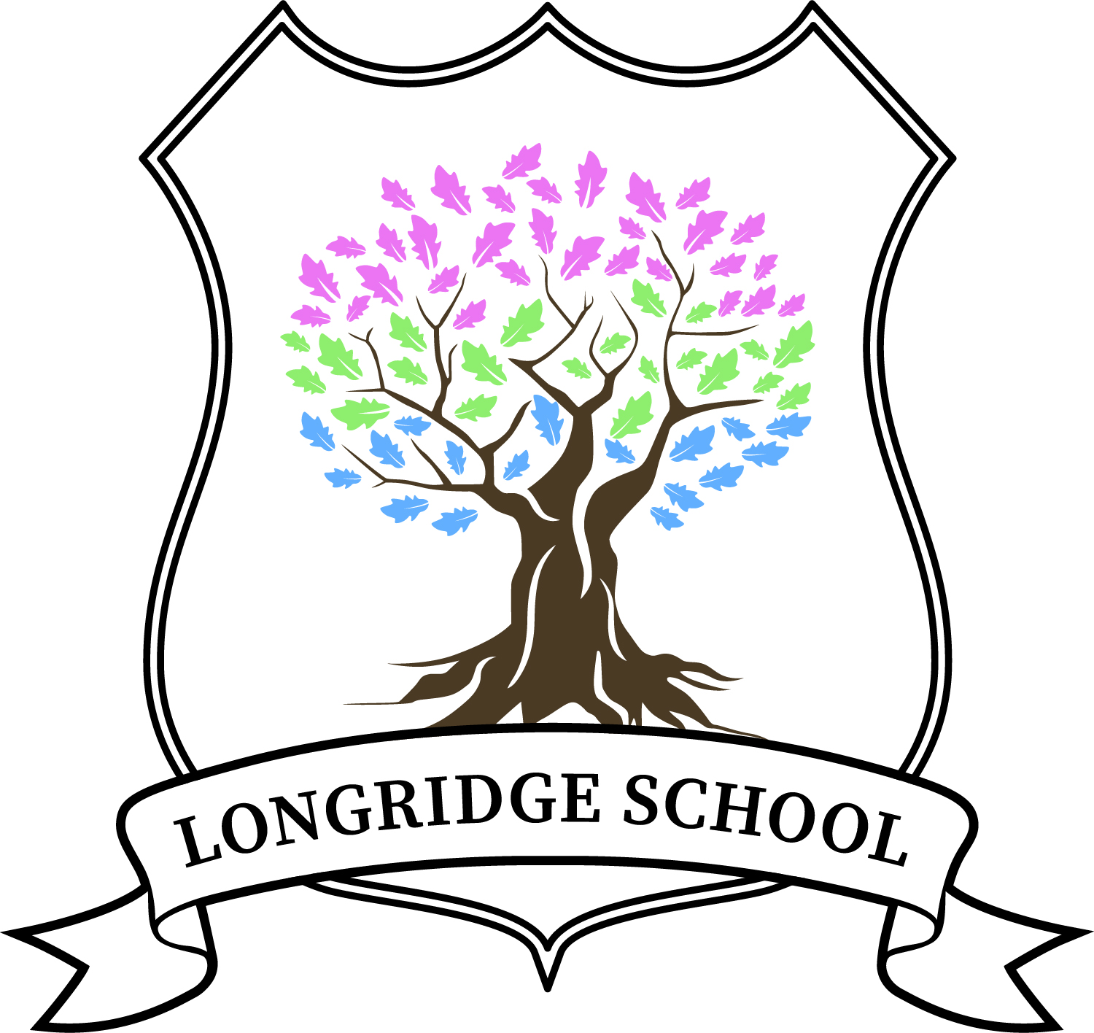

Disability, Equality &
Accessibility Policy


Our school’s ethos relating to equality

We are committed to ensuring equality of education and opportunity for all learners, staff and those receiving additional services from the school. We strive to develop a culture of inclusion and diversity in which people feel safe to disclose any disability or difference, which they feel may impact on their ability to participate fully in school life. We will make reasonable adjustments to make sure that the school environment is as accessible as possible. We believe that diversity is a strength, which should be respected and celebrated, by all those who learn in, teach at or visit Longridge School.

The Equality Act

The Equality Act 2010 replaces the Disability Discrimination Act 2005 (DDA). The Equality Act states that it. ‘Is unlawful for a school to discriminate against a pupil by treating them less favourably because of their –
- Gender
- Race
- Disability
- Religion or belief
- Sexual orientation
- Gender reassignment
- Pregnancy or maternity
The Act defines four types of unlawful behaviour –
- Direct discrimination
- Indirect discrimination
- Harassment
- Victimisation
Whilst the act is very clear that schools should not treat people differently because of the factors listed above there is one clear exception; in the case of disability the Act is clear that a disabled person must often be treated more favourably in order that they can benefit from what the school has to offer.

The definition of a disability as defined in the Act is –
‘Physical or mental impairment which has a substantial and long term adverse effect on that person’s ability to carry out normal day to day activities.’

Reasonable adjustment

The Act places responsibility on a school to make reasonable adjustments where something in the school places a disabled learner at a disadvantage, including using auxiliary aid or service if this would alleviate the disadvantage. The Act also requires schools to have “due regard” for equality issues when making significant decisions or developing policies.

School’s duties around accessibility for the disabled

Schools must implement accessibility plans which aim to –
- Increase the extent to which disabled learners can participate in the classroom.
- Improve the physical environment.
- Improve the availability of accessible information to disabled learners.
When providing newsletters and information for parents and carers, Longridge School will make this information available in an accessible format, if requested so that parents or carers who may be, for example, visually impaired, can access the information. Additionally, events for parents and carers such as open evenings, meetings with teachers, will be held in accessible parts of the building.

Compliance with Public Sector Equality Duty

Longridge School is a learning environment designed to cater for individual needs. Our compliance can therefore be met by working individually with each referred student and those adults supporting him/her to ensure their needs are met at the point of referral. Statements of SEN/EHCP’s can be vital in identifying, clarifying and responding to individual student’s educational needs.

The school does not contain sufficient numbers for statistical analysis of the performance of certain student groups, none the less academic achievement trends will be monitored in order to consider whether there are any underperforming categories. Through its whole curriculum and in particular PSHE, English and RE, the school will foster improved understanding of difference and good relations. Students and staff have the opportunity to raise equality concerns and issues for further discussion and exploration through student council meetings and staff meetings respectively.

Supporting Transgender individuals
The Equality Act 2010 ensures legal protection against direct or indirect discrimination for everyone under the 9 protected characteristics defined in the Act. Gender reassignment is one of the protected characteristics.

At Longridge School we will promote transgender equality through;
- Using the curriculum to challenge gender stereotypes and develop understanding of trans issues
- Covering trans issues in equality training for teaching staff
- Supporting lesbian, gay, bisexual and trans (LGBT) national awareness events and celebrating trans people and their achievements where appropriate
In working with a trans student, Longridge School will;
- avoid seeing the pupil as a problem and instead see an opportunity to enrich the school community and to challenge gender stereotypes and norms on a wider scale
- Listen to the learner and their parents/carers and wherever possible follow their lead and preferences
- Avoid, where possible, gender segregated activities. Where this cannot be avoided, allow the learner to access the activity that corresponds to their gender identity
- Consult with New Reflexions therapy department to ensure that it is in the child’s interest; to respect and use the student’s preferred name and pronoun, including in the school’s admin register and for the DfE census. Students can be entered under any name with an exam board. However, once a result is accredited it will need to be linked with a Unique Pupil Number (UPN) or Unique Learner Number (ULN) which existed in the school census information submitted in January of the exam year. UPNs and ULNs are only linked with legal names, not preferred names. It is however possible for exam certificates to be issued in the preferred name. The exams officer at Longridge School will ensure a strategy is agreed with the pupil or student and their parents or carers, then liaise with the exam boards prior to starting the process to accredited courses. Some exams may be sat in Year 10 and the length of time the process of re-registering may take has to be considered.
All toilets are single unisex facilities at Longridge school and all pupils are given respect and privacy when changing for PE activities.

Equality for staff

The Act requires that a school must not discriminate against an employee or a potential employee. Schools must make reasonable adjustments in relation to employees as they do for their pupils. Wherever possible Longridge School will seek to make reasonable adjustments for staff with disabilities which may include –
- Altering working hours
- Changing the location of the person's main area of work
- Allowing absences during working hours for rehabilitation, assessment or treatment
- Examining the duties allocated to a disabled member of staff to see where additional support may be required
- Supplying additional training
- Acquiring or making changes to equipment
- Altering premises
- Transferring the person to fill an existing vacancy, for example: if a teacher becomes disabled and there is no reasonable adjustment that can enable them to continue in their current post, they might be considered for another suitable post
Increasing access in the classroom

Longridge School will make reasonable adjustments for disabled students by –
- Differentiating the curriculum to suit each individual learner.
- Developing a vision and values based on an inclusive ethos.
- Encouraging a positive attitude from all staff to overcome barriers for disabled learners.
- Liaising effectively with parents, carers and specialists who can offer advice and support about what is effective.
- Allowing learners to have a meaningful voice and to be consulted effectively.
- Having a positive approach to managing behavior.
- Ensuring effective staff training and development.
- Building disability into day to day resourcing arrangements.
- Adopting a sensitive approach to meeting the specific needs of learners.
- Making available role models and positive images of disability.
- Using access arrangements appropriately in supporting learners to take examinations.
Longridge School strives to create a happy, safe and inclusive environment, which supports the development of independent, healthy and confident learners. We encourage all our learners, including those with a disability, to aspire to high standards, become economically aware, and make a positive contribution to a wider community.

Longridge School seeks to challenge inequality through –
- Promoting equal opportunities for all, regardless of gender, race, disability, religion, or sexual orientation, and making reasonable adjustments to the curriculum where required to cater for the needs of all learners.
- Setting high standards and realistic targets for all learners.
- Providing a safe and secure learning environment for all learners.
- Developing learner collaboration and independent learning opportunities.
- Making sure that all learners have opportunities to develop positive self-esteem.
- Encouraging all learners to become literate and numerate, in order to communicate effectively.
- Assessing learners for access arrangements as appropriate
- Promoting positive attitudes in students, to help them to develop socially, morally and spiritually, so that they can make positive and safe choices.
- Encouraging awareness and acceptance of disability, both in and out of the classroom.
- Ensuring that each learner is treated as an individual and specific needs are met.

Improving the physical environment

There are currently two areas of concern with respect of the physical environment at Longridge school–
- Accessibility to exterior storage area up small flight of steps.
- Redevelopment of the outdoor green spaces

If required, a ramp would be built to provide access to the storage area (currently only accessed by school staff).
Work is planned from September 2021 to begin landscaping the outdoor area and make this accessible to all staff and pupils regardless of physical disability.

Improving the availability of accessible information

Longridge School will strive to make all of their information available to each individual and assess personal need as from the point of referral to the school. Parents and carers should inform the school if they have any difficulties accessing information, so that necessary adjustments can be made.
In such a small environment all responses are bespoke and individualised and therefore we are in a strong position to ensure that individuals do not experience difficulties with accessing information or physical spaces.

Equality Objective 2021/2022

- To continue to promote equality through the school curriculum and displays, including having particular regard for balancing gender and religious role-models and being sensitive to LGBTQ issues.

Response to Equality Issues 2020/2021

- N/A

Last reviewed | Sept 2021
Next review due | Sept 2024
Reviewed by | Headteacher

