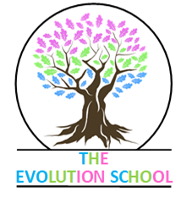

Full time Primary School Teacher, permanent contract
Salary £27 – 38,810 dependent on experience
The Evolution School is an OFSTED “good” Independent Primary School for students with social, emotional and behavioural difficulties, based in a rural location in Bicton, to the west of Shrewsbury.
You must have experience working with vulnerable and challenging young people, as well as the ability to think strategically whilst employing good organisational and time management skills. A sense of humour and a willingness to become absorbed into the breadth of school life is important. In our small, nurturing environment you will be able to genuinely make a difference; having the time to provide the attachment-based nurture and support that our students need to be successful. We broadly follow the national curriculum and have a topic-based approach to much of our learning. We generally follow the Shropshire Council school holidays, although our 5 inset days are sometimes different.
We are driven by the needs of the children and are committed to bespoking the curriculum to make it assessable to all.
We can offer a supportive hardworking team, a progressive approach towards professional development and a positive, problem-solving working environment. We would be open to the possibility of job share if timetabling allows. If you would like to find out more or visit the school for a tour, please contact the Deputy Head, Julia Kelly on 01743 850517.
Please note that we are committed to safeguarding and promoting the welfare of children and young people and we expect all employees to share this commitment. Therefore, the successful candidate for this post will be subject to an enhanced DBS check and our safer recruitment process.

