Longridge School
Risk Assessment Policy
September 2021

Contents:
Statement of intent
1. Legal framework
2. Definitions
3. Roles and responsibilities
4. Health and safety
5. Safeguarding
6. Assessing pupils’ welfare
7. Areas of risk
8. Risk ratings
9. Principles of effective risk management and assessment
10. Step 1 – identify the hazards
11. Step 2 – decide who might be harmed and how
12. Step 3 - evaluate the risks
13. Step 4 – record the findings
14. Step 5 – review
15. Training
16. Monitoring and review
Appendices
a) Sexual Behaviour Checklist
b) Checklist of Sexual Behaviour in pupils with SEND
c) When to Conduct a Welfare/Pastoral Risk Assessment
d) Identifying Risks in the School
e) Risk Assessment Review Template

Statement of intent
At Longridge School, we are committed to providing a safe and healthy working environment that inspires and supports academic achievement.

This policy sets out the procedures the school will follow in order to identify and manage the health and safety of staff members, pupils and visitors who may be affected by the school’s activities.

The purpose of a risk assessment is to enable the school to determine what measures should
be taken to comply with the duties under the relevant statutory provisions.

This policy will be adhered to by all staff members and the proprietal board at all times.

1. Legal framework
1.1. This policy has due regard to statutory legislation and guidance including, but not
limited to, the following:
- Health and Safety at Work etc Act 1974
- The Management of Health and Safety at Work Regulations 1999
- The Reporting of Injuries, Diseases and Dangerous Occurrences Regulations 2013 (RIDDOR)
- DfE (2014) ‘Health and safety: advice on legal duties and powers’
- DfE (2021) ‘Keeping children safe in education’
- Counter-Terrorism and Security Act 2015
1.2. This policy has been developed in accordance with, and will be implemented alongside, the following school policies and documents:
- Health and Safety Policy
- Child Protection and Safeguarding Policy
- Fire Safety Policy
- Educational Visits and School Trips Policy
- Fire Safety Risk Assessment
- Anti-Bullying Policy
- Whistleblowing Policy
2. Definitions
For the purpose of this policy:
2.1. “Risk assessment” is defined as a careful examination of what, in the school,
could cause harm to people, so that the school can determine whether the
necessary precautions are in place or whether more should be done to prevent
harm.
2.2. “Hazard” is defined as anything that may cause harm, such as chemicals, electricity, working from ladders, an open drawer, etc.

2.3. “Risk” is defined as the chance, low to high, that someone could be harmed by itand other hazards, together with an indication of how serious the harm could be.

2.4. “Dynamic risk assessment” is defined as an assessment that takes into account unexpected or short, temporary changes that require immediate amendments to be made to control measures.

2.5. “Generic risk assessment” is defined as an individual assessment covering the common, significant hazards that staff and others face on a daily basis, such as low-risk activities or repeated activities that can be documented in another way.
2.6. “Suitable and sufficient risk” is defined as an assessment that is proportionate to the risk and ensures that all relevant hazards are addressed, complies with statutory requirements, ensures all groups who are affected are considered, takes account of existing control measures and identifies further measures as necessary.

3. Roles and responsibilities

3.1. The directors are responsible for:
- The overall responsibility of risk management at the school.
- Delegating strategic decisions for operational management of risk and health and safety to the head teacher.

3.2. The head teacher is responsible for:
- Ensuring potential hazards are identified and risk assessments are carried out as appropriate.
- Ensuring that any individual tasked to carry out a risk assessment is suitably trained to do so.
- Allocating resources in response to risk assessments and determining a course of action, if it has been identified that a risk cannot be suitably controlled so far as is reasonably practicable.
- Implementing frameworks for decision-making and corporate strategies which consider risk assessment principles.
- Implementing appropriate mechanisms to communicate safe systems of work identified as part of the risk assessment process.
- Communicating elements of risk and health and safety management to the directors.

3.3. Staff members are responsible for:
- Taking reasonable care of their own safety, as well as that of pupils, visitors and other staff members.
- Undertaking their work in accordance with training and instructions.
- Cooperating with the school on health and safety matters.
- Carrying out assigned risk assessments effectively, ensuring all risks are identified as well as suitable control measures.
- Reporting any risks or defects to the head teacher in order to create new, or update, risk assessments.
- Participating in risk management training delivered by the school.

4. Health and safety

4.1. In accordance with the school’s Health and Safety Policy and requirements under The Management of Health and Safety at Work Regulations 1999, the school will assess the risks to the health and safety of staff, pupils and others affected by the school’s activities.

4.2. The school will ensure that a common-sense and proportionate approach is applied to risk assessment management – the school understands that a separate written risk assessment is not required for every activity.

4.3. The head teacher is responsible for ensuring potential hazards are identified and risk assessments are completed for all areas of risk in the school.

4.4. Yearly risk assessments of high-risk areas, such as laboratories, will be conducted.

4.5. Annual risk assessments will be conducted for all other areas of the school.
4.6. In accordance with 4.4 and 4.5, the head teacher will ensure that any individual assigned to carrying out a risk assessment understands the risks and is familiar with the activity that is planned.

4.7. The head teacher will ensure risk assessments are completed by staff leading day trips or residential stays.

4.8. For activities that are higher risk, if these are annual or infrequent activities, a review of an existing risk assessment will take place, rather than a newly written risk assessment.

4.9. Where a new activity is taking place, a specific risk assessment of significant risks will be conducted.

4.10. Where an activity usually forms part of a school day, e.g. pupils regularly undertaking swimming lessons at an alternative location, the school will not conduct separate risk assessments for each visit – termly checks will be conducted to ensure the precautions implemented remain suitable and any changes will be made as necessary.

4.11. Risk assessments will be updated in line with section 14 of this policy.

4.12. Risk assessments will identify all defects and potential risks along with necessary
solutions or control measures.

4.13. The school has developed a number of different risk assessments to address the requirements outlined in Annex A of the DfE’s ‘Health and safety: advice on legal duties and powers’, which includes the following where required;
- Training of staff in health and safety, including risk assessment
- Consultation arrangements with employees
- Recording and reporting accidents to staff, pupils and visitors – including
- those reportable under RIDDOR
- Procedures for off-site visits, including residential visits and any school-led adventure activities
- Responding to health and safety emergencies, Evacuation procedures
- First aid and supporting those with medical needs
- School security
- Violence to staff
- Manual handling
- Slips and trips
- On-site vehicle movements
- Management of asbestos
- COSHH
- Working at height
- Selecting and managing contractors
- Maintaining plant and equipment, such as electrical equipment, local exhaust ventilation, pressure systems, gas appliances, lifting equipment and glazing safety
- Fire safety, including test of alarms and evacuation procedures

NB. The above are also covered in the school’s Health and Safety Policy.

5. Safeguarding

5.1. In accordance with ‘Keeping children safe in education’ (KCSIE), the school recognises its specific safeguarding duties with regards to risk assessments.

5.2. The head teacher will undertake a risk assessment when deciding whether to obtain an enhanced DBS certificate for any volunteer not engaging in regulated activity. The following will be considered:
- The nature of the work with pupils
- What the school knows about the volunteer, including formal or informal information provided by staff, parents and other volunteers
- Whether the volunteer has other employment or undertakes voluntary activities where referees can advise on suitability
- Whether the role is eligible for an enhanced DBS check

5.3. All details of the risk assessment conducted in line with 5.2 will be recorded.

5.4. Where there is a possible suspension of a staff member, the school will conduct a risk assessment to determine their decision.

5.5. Where there has been a report of sexual violence, the DSL will undertake an immediate risk assessment. If there has been a report of sexual harassment, the need for a risk assessment will be considered on a case-by-case basis by the DSL.

5.6. In line with 5.5, the risk assessment will address the following:
- The victim – particularly their protection and support
- The alleged perpetrator
- All other pupils (and adult students or staff if appropriate) at the school, especially any actions required to protect them

5.7. The risk assessment conducted under provisions 5.5 and 5.6 will be recorded and kept under review by the DSL.

5.8. Any risk assessments conducted by professionals following an incident in line with 5.5 will be used by the DSL to inform the school’s risk assessment. The school’s risk assessment does not act as a replacement to risk assessments conducted by professionals.

5.9. Where a pupil is convicted or receives a caution for a sexual offence, the DSL will update the risk assessment to ensure relevant protections are in place for all pupils at the school.

5.10. As required by section 26 of the Counter-Terrorism and Security Act 2015, the school will conduct a risk assessment to determine the appropriateness of any filters and monitoring systems needed to control the risk of pupils being drawn into terrorism.

6. Assessing pupils’ welfare

6.1. Where any of the following criteria are met, the school will conduct a risk assessment regarding pupils’ welfare by following steps 1-5 identified in 8.2:
- A pupil with a clinical tendency towards behavioural, social and emotional difficulties, e.g. a pupil with autistic spectrum disorder.
- A pupil with a historical tendency towards behavioural, social or emotional difficulties.
- A pupil either returning to the school after a fixed-term exclusion or joining from another school after a permanent exclusion.
- A pupil with either a clinical tendency or historical tendency towards behavioural, social or emotional difficulties and participating in any off-site school visits/trips.

6.2. All risk assessments regarding pupils’ welfare will take into account previous behaviour, and outline specific measures, including both appropriate sanctions and pastoral support, to ensure the risk of behaviour being repeated is minimised and managed.

6.3. Care will be taken to ensure that pupils with SEND are not excluded from school activities as a result of behavioural difficulties, alternative options will be discussed and agreed if such behaviour would directly interfere with the education of other pupils.

6.4. The school will refer to Appendix C when making risk assessment decisions about pupils’ welfare or pastoral needs.

7. Areas of risk

7.1. The school identifies key areas of school management that present risks to the school community – these include, but are not limited to, the following:
- Safeguarding (as outlined in section 5)
- Pupil welfare
- Health and safety (as outlined in section 4)
- Security
- Fire safety
- Critical incidents
- School trips
- Staff recruitment

7.2. Specific risk assessments by professionals are also conducted under the following categories:
- Asbestos
- Legionella
- Gas safety
- Electrical safety
- Fire safety

8. Risk ratings

8.1. Longridge school uses a risk rating to assist in deciding whether an activity is safe to proceed. The risk rating is calculated by multiplying the likelihood of injury by the severity of the injury, which is then expressed as a %. This can easily be determined using the risk rating calculator below:

Likelihood

Severity | 1  Unlikely  Extremely unlikely to ever occur | 2  Possible  Unlikely but may occur exceptionally | 3  Quite Possible  Likely to occur at some time | 4  Likely  Likely to occur often | 5  Very Likely  Regular or continuous occurrence
5  Multiple Fatalities | 5 (20%) | 10 (40%) | 15 (60%) | 20 (80%) | 25 (100%)
4  Single Fatality | 4 (16%) | 8 (32%) | 12 (48%) | 16 (64%) | 20 (80%)
3  Major Injury/Injuries | 3 (12%) | 6 (24%) | 9 (36%) | 12 (48%) | 15 (60%)
2  Lost Time Injury | 2 (8%) | 4 (16%) | 6 (24%) | 8 (32%) | 10 (40%)
1  First Aid Injury | 1 (4%) | 2 (8%) | 3 (12%) | 4 (16%) | 5 (20%)

8.2. In line with 8.1, the school has identified the following risk actions depending on
the determined risk rating:
 | Risk Rating | Priority
41% - 100% | High | Work should not start or continue until the risk has been reduced. If it is not possible to reduce the risk, irrespective of cost then activity must be prohibited. If the activity is in progress it must be stopped and alternative safe means of carrying out the activity identified.
17% - 40% | Medium | Establish more precisely the likelihood of harm as a basis for determining the need for improved control measures. Additional controls must be implemented to reduce the risk. Regular monitoring of existing controls is essential.
0% - 16% | Low | No significant additional controls are necessary. Regular monitoring of existing controls is essential.

8.3. When completing risk assessments, staff members will grade impact and likelihood using the above scale systems and respond appropriately in line with 8.2.
9. Principles of effective risk management and assessment

9.1. The school adopts the following key principles of risk prevention:
- If possible, avoid a risk altogether
- Avoid introducing new hazards
- Evaluate unavoidable risks via a risk assessment
- Combat risks at the source
- Consult with those affected to adapt work to the requirements of the individual
- Take advantage of technological and technical progress
- Implement risk prevention measures within a policy
- Give priority to protection measures that safeguard the whole school
- Ensure that staff and pupils understand what they must do to minimise risk
- Develop a positive approach to health and safety within school

9.2. The school identifies a five-stage process to undertaking a risk assessment:
1. Identify the hazards
2. Decide who might be harmed and how
3. Evaluate the risks
4. Record the findings
5. Review

9.3. The school understands that most hazards are easy to recognise, e.g. in the science department, the use of toxic or dangerous chemicals should already have an assessment under the COSHH.

9.4. Hazards that are already covered under other risk assessment will be ticked as ‘checked’ in the general risk assessment. There is no need to conduct a separate risk assessment.

10. Step 1 – identify the hazards

10.1. When identifying hazards, staff members will:
- Walk around the area and assess what could reasonably be expected to cause harm.
- Put themselves in the place of non-specialist staff and pupils to find the risks.
- Ignore the trivial and concentrate only on significant hazards that could result in serious harm or affect several people.

10.2. To identify hazards, staff members will have regard to the following:
- Slipping and tripping hazards, e.g. poorly maintained floors or stairs
- Fire, e.g. from flammable materials
- Chemicals and how they are used, and in what quantities, e.g. cleaning chemicals
- Moving parts of machinery, e.g. within faculty workshops
- Ejection of materials, e.g. workshops and experiments
- Electricity, e.g. poor wiring, portable appliances, electrical experiments
- Fumes, e.g. welding and chemicals
- Manual handling
- Noise
- General environment, e.g. poor lighting or low/high temperature
- Biological hazards, e.g. gardening or contact with bodily fluids
- Behaviour management, e.g. kicking, hitting, verbal abuse, threats/aggression, running away, vandalism, bullying or stealing
- Prior exclusion
- Inappropriate sexual behaviour (refer to appendix A and B)

11. Step 2 – decide who might be harmed and how

11.1. In addition to staff, those conducting a risk assessment will also consider people who may not be in the workplace consistently, e.g. cleaners, visitors, parents or maintenance personnel.

11.2. Staff will have regard to the following groups of people:
- Staff members
- Operators
- Maintenance personnel
- Cleaners
- Contractors
- Members of the public
- Parents
- Pupils

11.3. Staff will also have due regard to the following vulnerable groups:
- Staff and student staff/pupils with disabilities
- Inexperienced staff
- Visitors
- Lone workers
- Pregnant workers

12. Step 3 – evaluate the risks

12.1. Staff will evaluate the risks arising from the hazards and decide whether existing precautions are adequate or more should be done in line with section 7 of this policy.

12.2. For each significant hazard, staff will decide whether the residual risk is high, moderate or low.

12.3. Staff will consider whether industry standards are in place and whether all has been done that is reasonably practicable to keep the workplace safe.

12.4. Staff will ensure that managing additional hazards does not interfere with other control measures, such as fire safety.

12.5. Staff will ensure that the following are in place:
- Adequate information, instruction or training
- Adequate systems or procedures

12.6. When implementing control measures, staff will have due regard to whether the
precautions:
- Meet the standards set by a legal requirement.
- Comply with the recognised industry standard.
- Represent good practice.
- Change existing precautions in place.

12.7. To reduce risks as far as reasonably practicable, staff will aim to eradicate the hazard completely, or control the risk significantly to ensure that harm is unlikely or the likelihood of it occurring is minimised.

13. Step 4 – record the findings

13.1. Staff will ensure that the most significant hazards are recorded, as well as the control measures in place to mitigate those hazards.

13.2. Staff do not need to show how the assessment was carried out provided that:
- A proper check was made.
- The assessment details who might be affected.
- All the obvious, significant hazards are considered, taking into account the number of people who could be involved.
- The precautions are reasonable, and the remaining risks are low.

13.3. All findings will be reported to the head teacher.

13.4. Where the impact or likelihood of major risks cannot be minimised, the head teacher will decide whether the activity will still take place.

14. Step 5 – review

14.1. Risk assessments will be reviewed yearly as a minimum.

14.2. There are no set statutory guidelines for the review of risk assessments. The school implements the following requirements for when risk assessments will be reviewed:
- When there are changes to an activity
- After a near-miss or accident
- When there are changes to the type of people involved in the activity
- When there are changes to good practice
- When there are changes to related legislation
- Annually, if for no other reason

14.3. Reviews of risk assessments will be dynamic – changes will be made immediately to the existing risk assessment. A new risk assessment will not be conducted unless there are significant changes, such as more than one of the criteria outlined in 14.2.

14.4. Risk assessments developed for high-risk activities will be reviewed on a termly basis by the individual who created the risk assessment and the head teacher.
14.5. All reviews will be recorded. Changes will be communicated to all relevant individuals immediately.

14.6. Risk assessments will be stored for the duration of the risk assessment, plus three years, in line with the school’s Records Management Policy.

14.7. Staff members will use the Risk Assessment Review Template in the appendices of this policy.

15. Training

15.1. All staff members will receive termly training on basic risk management procedures.

15.2. Staff members with a responsibility of creating and completing risk assessments, such as school trip leaders, will receive in-depth training on risk management on a termly basis, in addition to the basic risk management training offered.

15.3. All new staff members will receive training on risk management as part of their induction training.

16. Monitoring and review

16.1. This policy will be reviewed on an annual basis by the head teacher. The next scheduled review date for this policy is September 2022.

16.2. Any changes made to this policy will be communicated to all staff members by the head teacher.

16.3. All staff members are required to familiarise themselves with this policy as part of their induction programme.

Last Reviewed | Sept 2021
Next Review Due | Sept 2022
Reviewed by | Head Teacher

Sexual behaviour checklist

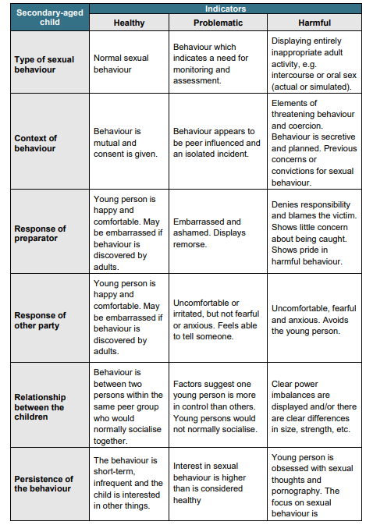
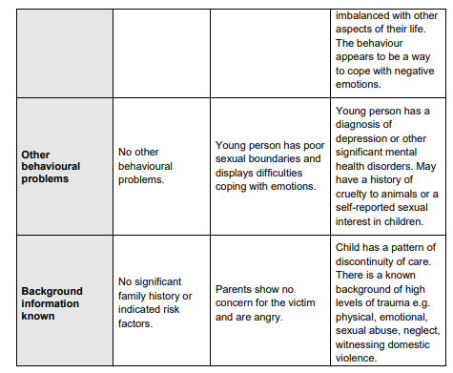

Checklist of sexual behaviour in pupils with SEND

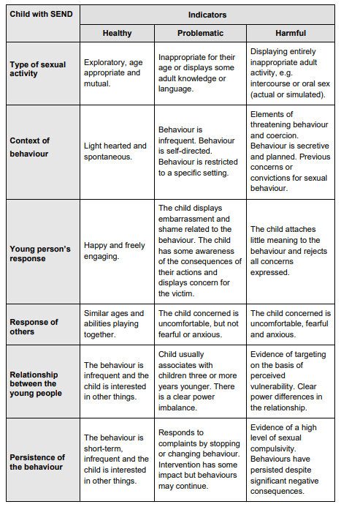

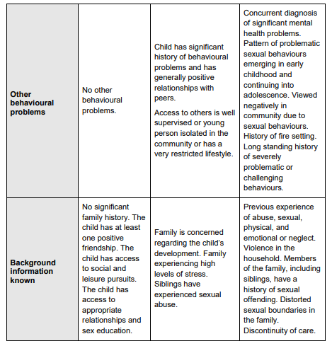

When to conduct a welfare/pastoral risk assessment

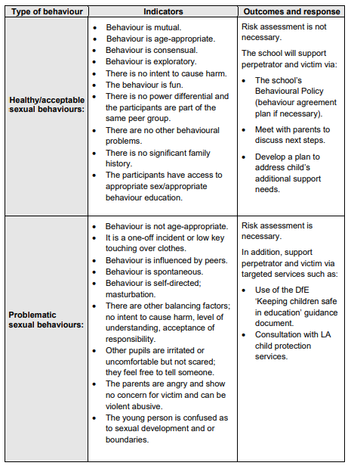

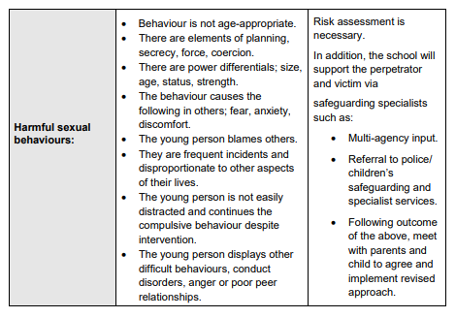

Identifying Risks in School

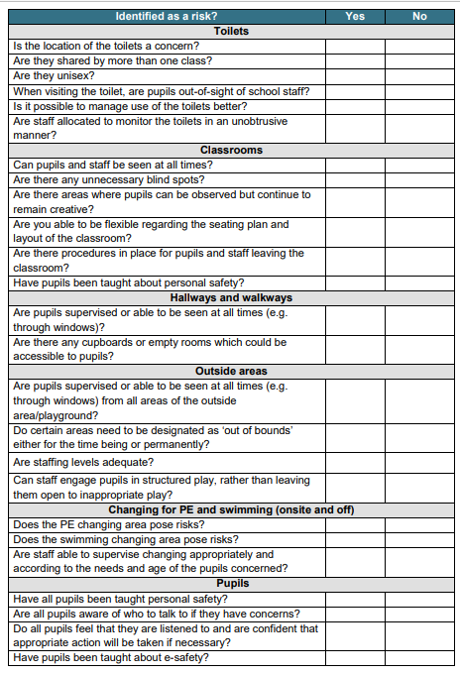

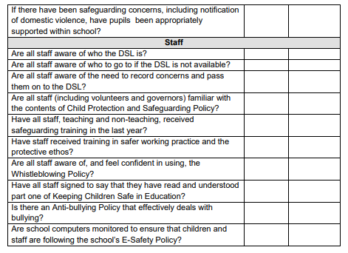

Hazard | Impact upon people | Current control measures | Likelihood  (1-5) | Impact  (1-5) | Total score | Risk rating, Low, medium, high | Additional control measures required
Risk Assessment Review Template

